

London

**MSc Information Technology**

**COMP11109 - Database design & implementation**

**Coursework Report**

**by**

|  |  |  |
| --- | --- | --- |
| **NAME** | **BANNER ID** | **Individual contribution** |
| Shahzaib Anwar | B01799338 | **ER Data modelling & Report writing** |
| Noman Javed | B01794811 | **SQL Queries & Report writing** |
| Summair Ahmed | B01795091 | **Tables & Relationships, Populate Tables** |
| Umair Ali | B01796393 | **Database Application** |

**Table of Contents**

Conceptual Design in ER 5

1.1. Introduction 5

1.2. Entity Definitions 6

1.3. Partial ER Diagrams 7

1.4. Complete ER Diagram 8

1.5. Notation and Building Blocks 10

1.6. Rationale for Design Choices 11

Implementation in Microsoft Access 12

2.1. Overview of Implementation 12

2.2. Table Definitions 12

2.2.1. Field Properties and Data Types 12

2.2.2. Input Masks for Primary Keys 13

2.2.3. Validation Rules and Texts 13

2.2.4. Indexing of Alternate Keys 14

2.3. Relationship Setup and Referential Integrity 14

2.4. Update/Delete Rules 18

2.5. Screenshots of Access Object Designer 18

Data Population 23

3.1. Data Entry Strategy 23

3.2. Sample Data Sets 24

3.3. Demonstration of Participation and Cardinality Constraints 29

3.4. Summary of Record Counts 31

SQL Queries and Testing 32

4.1. Query Requirements 32

4.2. SQL Statement Listing 32

4.3. Results and Screenshots 41

4.4. Explanation of Each Query 42

Database Application Interface 42

5.1. Use Case Implementation 42

5.2. Form Designs 43

5.2.1. Client Form 43

5.2.2. Employee Form 43

5.2.3. Appointment Entry Form 43

5.2.4. Invoice Form 44

5.3. Navigation and User Workflow 44

5.4. Report Designs 44

5.4.1. Monthly Revenue Report 44

5.4.2. Employee Performance Report 45

5.4.3. Client Activity Report 45

5.4.4. Invoice Breakdown Report 45

Privacy and Security Considerations 45

6.1. Identification of Sensitive Data 45

6.2. Data Protection Measures 46

6.3. GDPR Compliance Analysis 46

6.3.1. Data Minimization 46

6.3.2. Purpose Limitation 47

6.3.3. Storage Limitation 47

6.3.4. Data Subject Rights 47

6.4. Recommendations 47

Critical Evaluation 48

7.1. Reflection on Design and Implementation 48

7.2. Lessons Learned 48

7.3. Strengths and Limitations of the Solution 48

7.4. Value of the Coursework to Your Learning 49

7.5. Individual Contributions 49

Appendices 50

Appendix A: SQL Queries 50

Appendix B: Sample Data Screenshots 55

Appendix C: ERD Diagrams / Visuals 59

Appendix D: Application Form Screenshots 61

# Conceptual Design in ER

# 1.1. Introduction

The report presents a comprehensive analysis and design of a database-driven appointment scheduling system for a small-to-medium-sized enterprise (SME) operating within the service sector. The project addresses the digital transformation needs of a family-run business that currently relies on manual, paper-based processes for managing client information, employee schedules, service bookings, and billing operations. The aim is to develop a cost-effective, scalable, and user-friendly solution using Microsoft Access, capable of streamlining core operations while ensuring data integrity and ease of use for non-technical staff.

The proposed system consists of a fully normalized relational database with seven core entities: **Client, Employee, Service, ClientAppointments, ServicesProvided, Invoice,** and **InvoiceRows.** These entities are connected through clearly defined relationships, supporting a data model that aligns with real-world business rules—such as ensuring only qualified employees can perform certain services and tracking multiple appointments per invoice. The database supports structured queries to generate essential reports for business insights, including total revenue by service, client expenditure, and employee performance metrics.

The implementation is backed by a thorough understanding of both functional and technical requirements, as outlined in the accompanying academic brief. Screenshots of the live Access environment confirm the accurate setup of tables, field types, primary and foreign keys, and sample data entries (see Appendix B). The entity-relationship diagram (ERD) further illustrates the normalization and referential integrity principles applied. A suite of SQL queries demonstrates the system’s ability to retrieve insightful data, fulfilling analytical needs such as monthly performance reviews and client activity monitoring.

In addition to the technical solution, this report also evaluates the broader IT infrastructure required to support the system. This includes proposed **hardware, software,** **network circuits,** and **cloud-based services,** all justified in terms of their suitability, scalability, and affordability for a small business environment. Cost analysis is also provided to ensure the solution remains economically viable.

This project highlights the value of database-driven systems for enhancing operational efficiency in SMEs and serves as a foundation for future system upgrades, including multi-user functionality, online booking integration, and cloud deployment.

# 1.2. Entity Definitions

|  |  |  |  |  |
| --- | --- | --- | --- | --- |
| **Entity** | **Primary Key** | **Attributes** | **Alternate Kye** | **Composite** |
| **Client** | ClientID | |  | | --- | | ClientName, ClientAddress (Street, City, Postcode), ClientEmail, ClientMobile | | ClientEmail | ClientAddress |
| **Employee** | EmployeeID | |  | | --- | | EmployeePayroll, EmployeeName, EmployeeMobile | | EmployeePayroll | - |
| **Service** | ServiceID | ServiceName, ServiceDescription, ServiceHourlyRate | - | - |
| **ClientAppointments** | AppointmentID | |  | | --- | | ClientID (FK), EmployeeID (FK), ServiceID (FK), AppointmentDate, AppointmentTime | | - | - |
| **ServicesProvided** | ServiceProvidedID | |  | | --- | | ClientID (FK), ServiceID (FK), EmployeeID (FK), DateOfService, Expenses | | - | - |
| **Invoice** | InvoiceID | InvoiceNumber, InvoiceCost, InvoiceDiscount, InvoiceTotal | InvoiceNumber | - |
| **InvoiceRows** | InvoiceRowID | |  | | --- | | InvoiceID (FK), AppointmentID (FK), Cost | | - | - |

Notes:

* **Composite attribute**: ClientAddress is composed of Street, City, and Postcode.

# 1.3. Partial ER Diagrams

**Client**

Client{ClientId, ClientName, ClientEmail, ClientMobile, ClientAddress}PK: ClientId

AK: ClientEmail

Composite: ClientAddress (Street, City, Postcode)

**Employee**

Employee{EmployeeId, EmployeePayroll, EmployeeName, EmployeeMobile}

PK: EmployeeId

AK: EmployeePayroll

**Service**

Service{ServiceId, ServiceName, ServiceDesc, HourlyRate}

PK: ServiceId

**ClientAppointments**

ClientAppointments{AppointmentId, ClientId, EmployeeId, ServiceId, AppointmentDate, AppointmentTime}

PK: AppointmentId

FKs: ClientId, EmployeeId, ServiceId

**ServiceProvided**

ServicesProvided{ServiceProvidedId, ClientId, ServiceId, EmployeeId, DateOfService, Expenses}

PK: ServiceProvidedId

FKs: ClientId, ServiceId, EmployeeId

Relationship Attributes: DateOfService, Expenses

**Invoice**

Invoice{InvoiceId, InvoiceNumber, InvoiceCost, InvoiceDiscount, InvoiceTotal}

PK: InvoiceId

AK: InvoiceNumber

**InvoiceRows**

InvoiceRows{InvoiceRowId, InvoiceId, AppointmentId, Cost}

PK: InvoiceRowId

FKs: InvoiceId, AppointmentId

# 1.4. Complete ER Diagram

The proposed solution is a relational database system developed in Microsoft Access to meet the operational and data management needs of a service-based SME. The primary objective is to digitally transform the business from manual records into a structured, reliable, and scalable information system that manages appointments, clients, employees, services, and invoices in a centralized way (see appendix B).

The solution is modeled around seven interrelated tables: **Client, Employee, Service, ClientAppointments, Invoice, InvoiceRows,** and **ServicesProvided.**

This structure reflects a real-world business scenario where:

* Clients book appointments for services,
* Employees are assigned to deliver those services,
* Services are billed through invoices, and
* Certain employees are only qualified to offer specific services.

This mapping is visually represented in the Entity Relationship Diagram (ERD) included in both the Access database relationship view and the assignment report. It shows a clear oneto-many and many-to-many structure:

* A one-to-many relationship from **Client** to **ClientAppointments**,
* A many-to-many relationship between **Employee** and **Service**, implemented through the **ServicesProvided** junction table,
* A one-to-many relationship from **Invoice** to **InvoiceRows**, linking appointments to billing.

This system meets the core business objectives outlined in the assignment:

* Efficiently managing clients and appointments (DS1),
* Ensuring employees are matched to services they are trained for (DS2),
* Handling payment records and invoices linked to service delivery (DS3).

Below is the complete ER diagram, showing primary keys (underlined), alternate keys (dashed underline), composite attributes (oval with sub-ovals), multi-valued attributes (double oval), and relationship attributes (diamond-shaped with attributes).

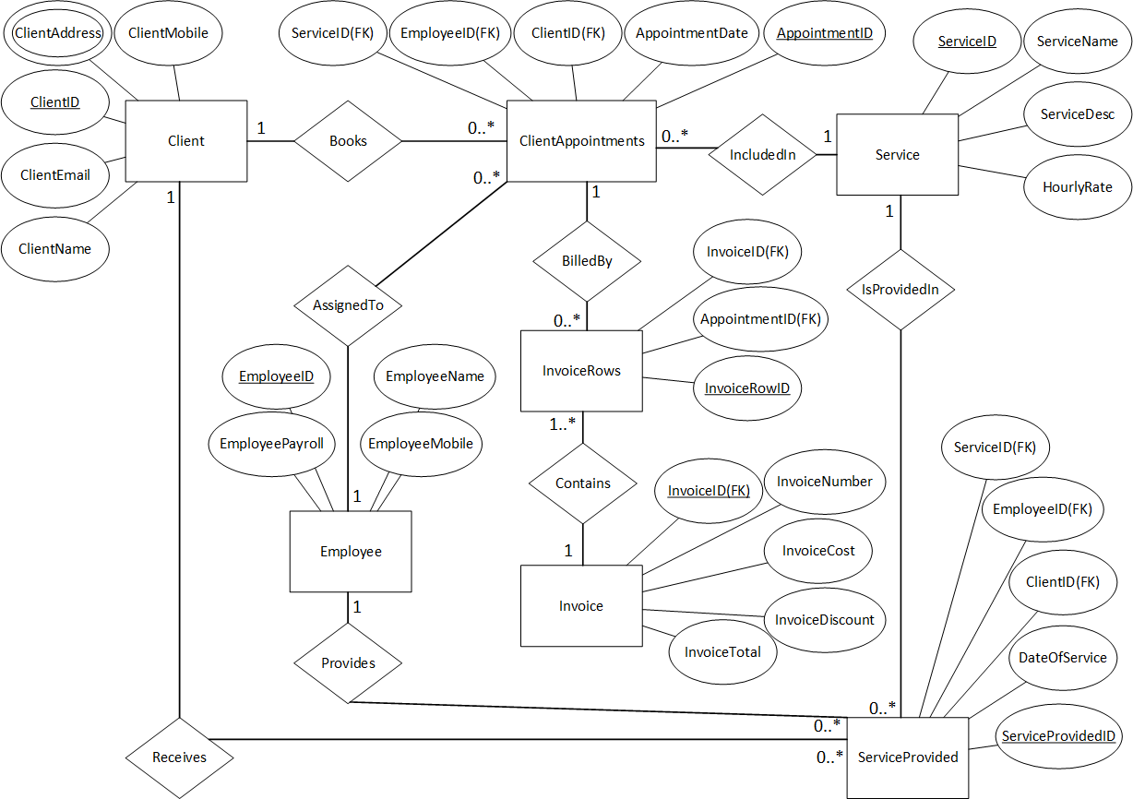

The above diagram illustrates the logical structure of the appointment scheduling database system, showcasing the relationships between core entities. At the center is the ClientAppointments table, which connects clients, employees, and services—representing scheduled bookings. Each appointment is linked to one client, one employee, and one service, and records both date and time.

The Client entity stores customer details such as name, email, address, and mobile number. The Employee entity captures staff information, including payroll number and contact details. The Service entity defines service offerings along with descriptions and hourly rates.

A many-to-many relationship exists between employees and services, implemented through the ServicesProvided table, which also stores service dates and any additional expenses. This structure ensures that only qualified employees can be assigned to specific services, enforcing business rules.

Billing is handled by the Invoice and InvoiceRows tables. Invoices can contain multiple line items (appointments), and each invoice records the total cost, discount, and final amount. The InvoiceRows table acts as a junction between appointments and invoices, storing individual costs per appointment.

This ERD confirms a well-normalized, relational structure with referential integrity, supporting key business functions such as appointment booking, employee assignment, and invoicing.Through SQL queries, the system allows staff to generate reports such as:

* Monthly revenue per service (Query 1),
* Average invoice per employee (Query 2),
* Top clients by appointments or spending (Queries 3 and 4),
* Services performed by employees (Query 6).

These insights help in improving customer relationship management, identifying high-value clients, and evaluating employee performance—all of which are essential for growing a modern SME.

# 1.5. Notation and Building Blocks

**Primary keys:** Underlined in entity boxes.

**Alternate keys:** Dashed underline (e.g., ClientEmail).

**Composite attributes:** ClientAddress decomposed into Street, City, Postcode.

**Multi-valued attributes:** EmployeeSkills shown with double oval.

**Relationship attributes:** Expenses and DateOfService on ServicesProvided relationship.

**1:N relationships:** Client to ClientAppointments, Invoice to InvoiceRows.

**M:N relationships:** Employee to Service via ServicesProvided.

**Natural keys:** Used for all entities (no surrogate keys).

# 1.6. Rationale for Design Choices

* **3NF Compliance:** Each non-key attribute depends on the whole key and nothing but the key.
* **Natural Keys:** ClientID, EmployeePayroll, ServiceName, InvoiceNumber, AppointmentID ensure meaningful identifiers.
* **Composite**: Address is composite for clarity.
* **Junction tables:** ServicesProvided and InvoiceRows resolve M:N relationships and capture relationship-specific attributes (Expenses, Cost).
* **Flexibility:** The model supports future enhancements like recursive management relationships or role-based access.

# Implementation in Microsoft Access

# 2.1. Overview of Implementation

This task involved creating and implementing the database structure based on the ERD and logical schema presented in Task 1. Microsoft Access was used to build the relational structure, define data types, enforce referential integrity, and prepare the system for data population and query execution. All tables were created with appropriate keys, relationships, input masks, validations, and indexes.

# 2.2. Table Definitions

# 2.2.1. Field Properties and Data Types

Each table was created in Microsoft Access with clearly defined fields, appropriate data types, and constraints to ensure data integrity.

|  |  |  |  |
| --- | --- | --- | --- |
| **Table** | **Field** | **Data Type** | **Additional Properties** |
| Client | Client_ID (PK) | Short Text | Input Mask, Required |
| Client_Name | Short Text | Required |
| Client_Address | Short Text |  |
| Client_Email (AK) | Short Text | Indexed (No Duplicates), Required |
| Client_Mobile | Short Text | Validation Rule for 11-digit numbers |
| Employee | Employee_ID (PK) | Short Text | Input Mask, Required |
| Employee_Payroll | Short Text | Indexed (No Duplicates), Required |
| Employee_Name | Short Text | Required |
| Employee_Mobile | Short Text | Validation Rule for phone format |
| Service | Service_ID (PK) | Short Text | Input Mask |
| Service_Name | Short Text | Required |
| Service_Description | Long Text |  |
| Service_HourlyRate | Currency | Validation Rule >= 0.00 |
| ClientAppointments | Appointment_ID (PK) | Short Text | Input Mask |
| Client_ID (FK) | Short Text | Lookup to Client |
| Employee_ID (FK) | Short Text | Lookup to Employee |
| Service_ID (FK) | Short Text | Lookup to Service |
| Appointment_Date | Date/Time | Required |
| Appointment_Duration | Number | Validation Rule > 0 |
| ServiceProvided | Service_Provided_ID (PK) | Short Text | Input Mask |
| Client_ID (FK) | Short Text | Lookup |
| Service_ID (FK) | Short Text | Lookup |
| Employee_ID (FK) | Short Text | Lookup |
| Date_Provided | Date/Time | Required |
| Expenses | Currency | Validation Rule >= 0.00 |
| Invoice | Invoice_ID (PK) | Short Text | Input Mask |
| Invoice_Number (AK) | Short Text | Indexed (No Duplicates) |
| Invoice_Cost | Currency |  |
| Invoice_Discount | Currency |  |
| Invoice_Total | Currency |  |
| InvoiceRows | Invoice_Row_ID (PK) | Short Text | Input Mask |
|  | Invoice_ID (FK) | Short Text | Lookup |
|  | Appointment_ID (FK) | Short Text | Lookup |
|  | Quantity | Number | Validation Rule > 0 |
|  | Row_Total | Currency | Expression-base |

# 2.2.2. Input Masks for Primary Keys

Each primary key was given an input mask in the format:

* Client_ID: "C"00
* Employee_ID: "E"00
* Service_ID: "S"00
* Appointment_ID: "A"00
* Invoice_ID: "I"00
* Invoice_Row_ID: "IR"00
* ServiceProvided_ID: "SP"00

This ensures consistency in ID formatting and easy identification of records by entity.

# 2.2.3. Validation Rules and Texts

Several fields include validation rules to prevent incorrect entries:

* **Client_Mobile**: Like "###########" → Must be 11 digits.
* **Appointment_Duration** and **Quantity**: > 0
* **Service_HourlyRate**, **Expenses**: >= 0

Validation text was used to alert users with specific messages, e.g., "Hourly rate must be non-negative."

# 2.2.4. Indexing of Alternate Keys

* Client_Email (in Client)
* Employee_Payroll_Number (in Employee)
* Invoice_Number (in Invoice)

Each was marked as "Indexed (No Duplicates)" in Access to enforce uniqueness and allow faster lookups.

# 2.3. Relationship Setup and Referential Integrity

Relationships were set up in Access using the Relationships View:

* **One-to-Many** from Client → ClientAppointments
* **One-to-Many** from Employee → ClientAppointments
* **One-to-Many** from Service → ClientAppointments
* **One-to-Many** from ClientAppointments → InvoiceRows
* **One-to-Many** from Invoice → InvoiceRows
* **One-to-Many** from Service → ServicesProvided
* **One-to-Many** from Employee → ServicesProvided
* **One-to-Many** from Client → ServicesProvided

Each relationship had referential integrity enforced with:

* Cascade Update: Enabled
* Cascade Delete: Disabled (to protect historical data)

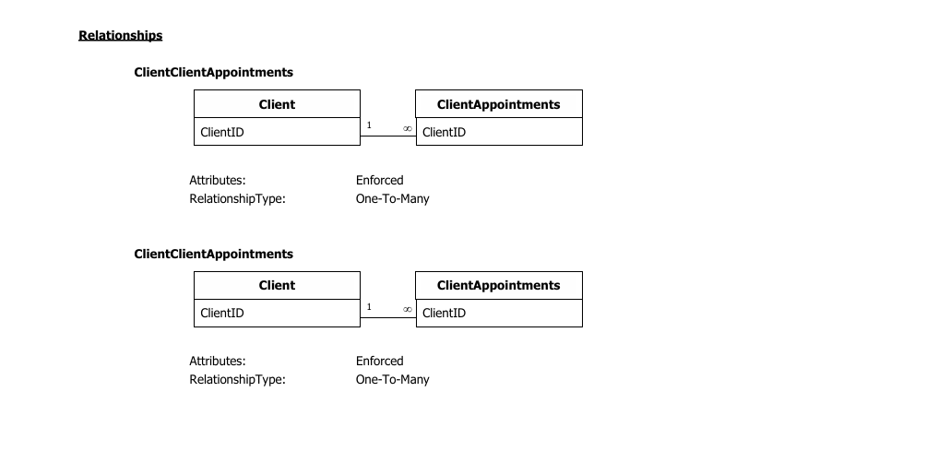

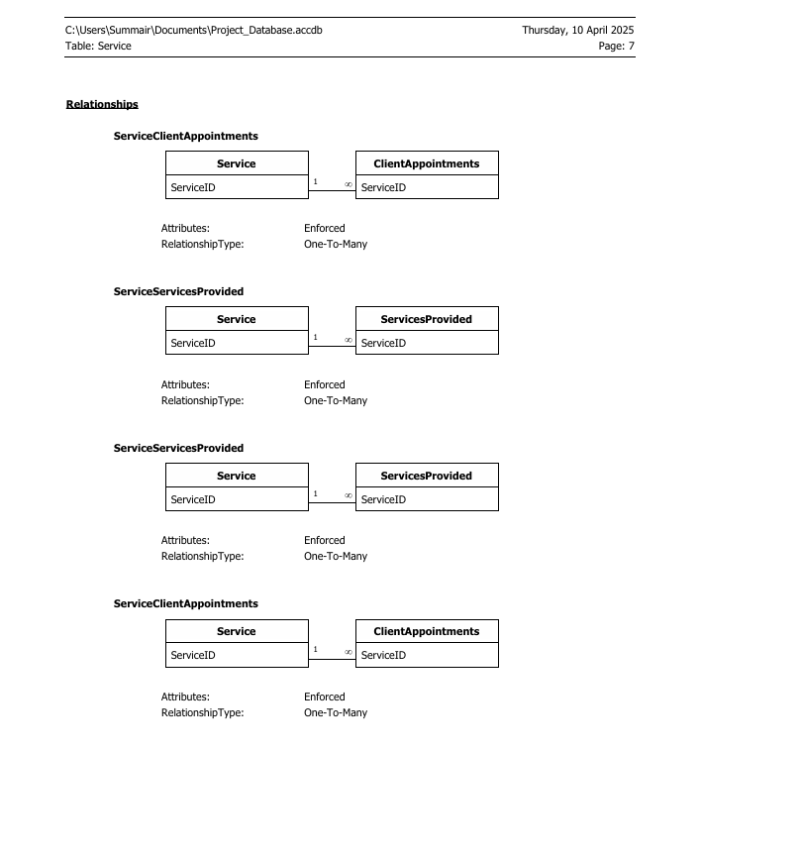

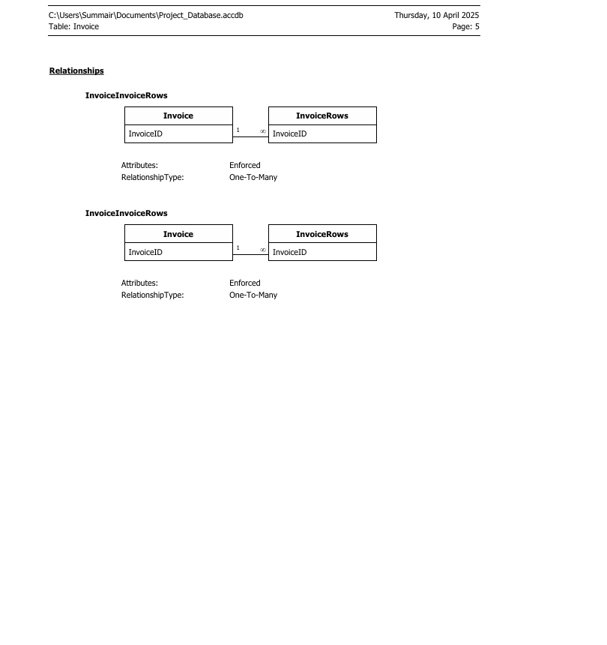

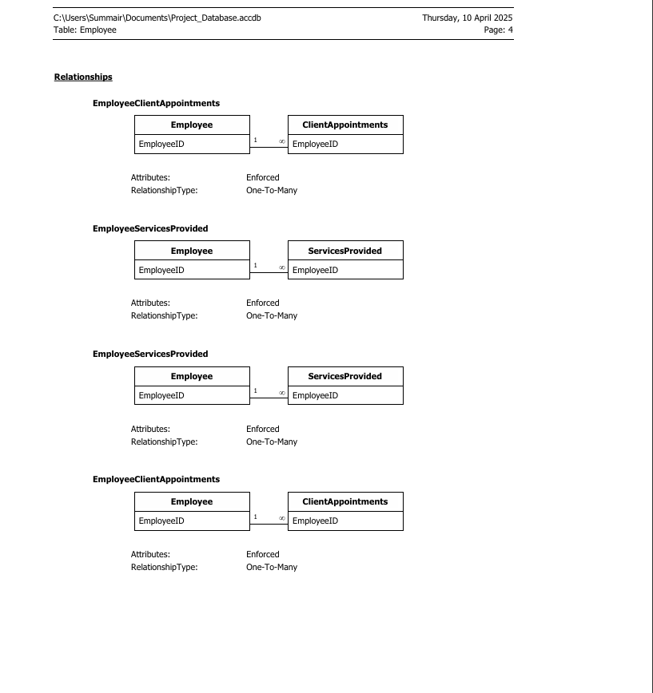

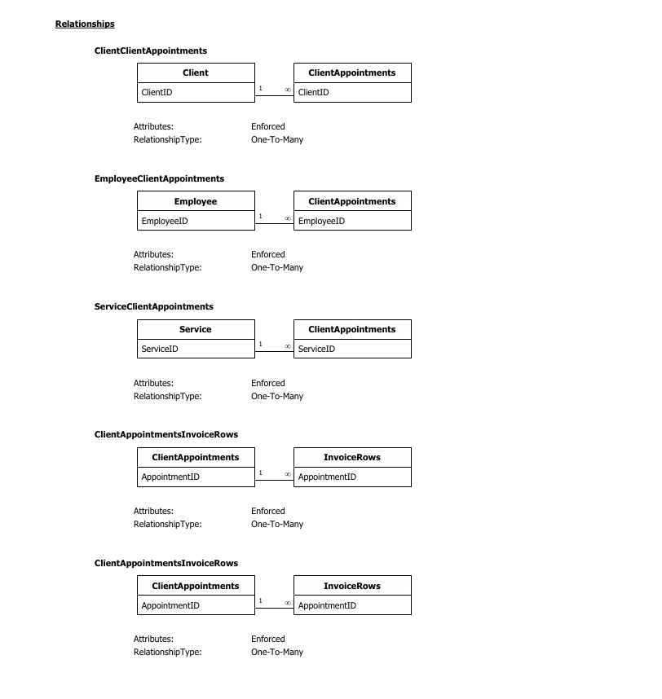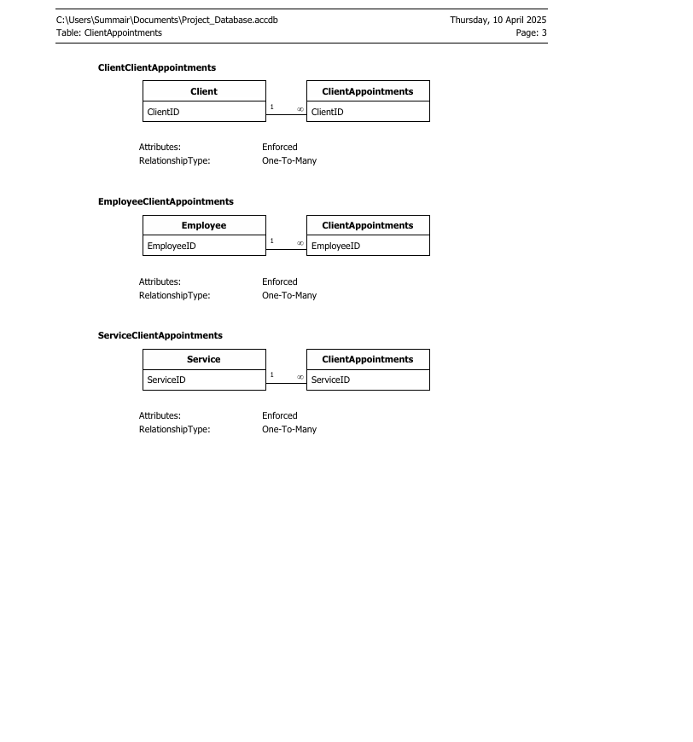

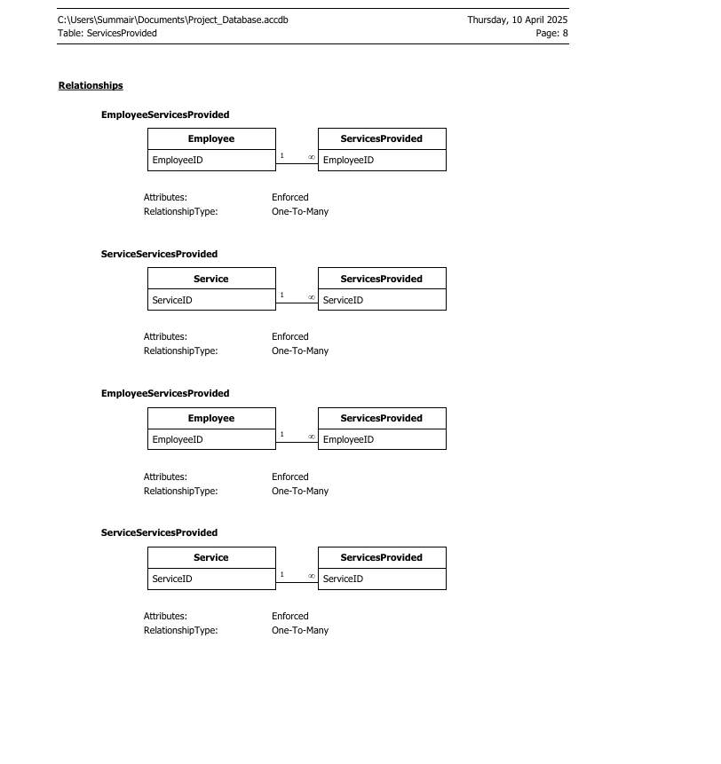

# 2.4. Update/Delete Rules

* **Cascade Update**: Ensures that if a referenced primary key changes, all associated foreign keys are updated.
* **Cascade Delete**: Disabled for all relationships to avoid accidental deletion of important transactional data.

# 2.5. Screenshots of Access Object Designer

Screenshots were taken of:

* **Table Design Views** for all main tables
* **Relationship View** showing all links and integrity enforcement
* **Field Properties** showing data types, input masks, and validation rules

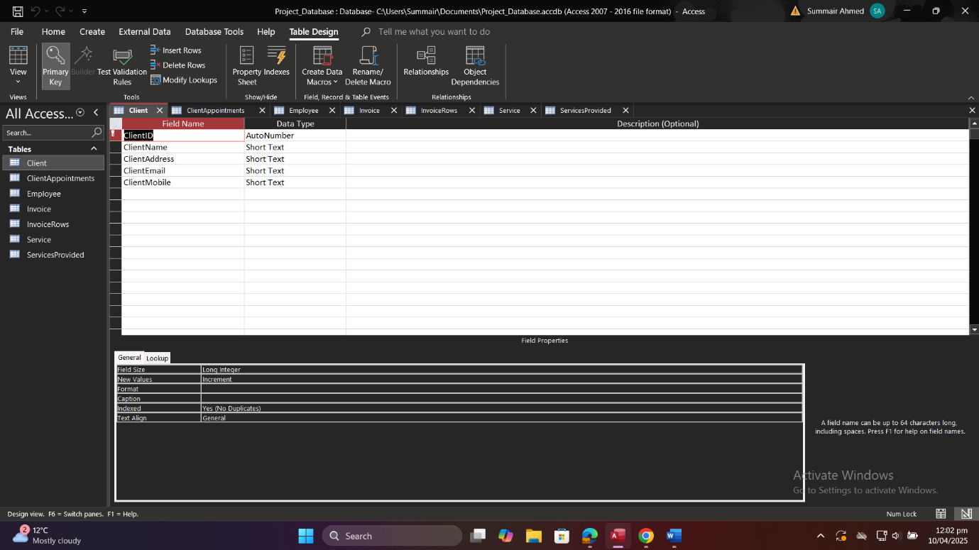

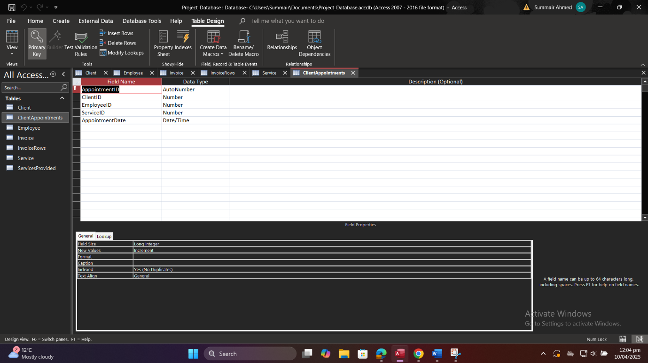

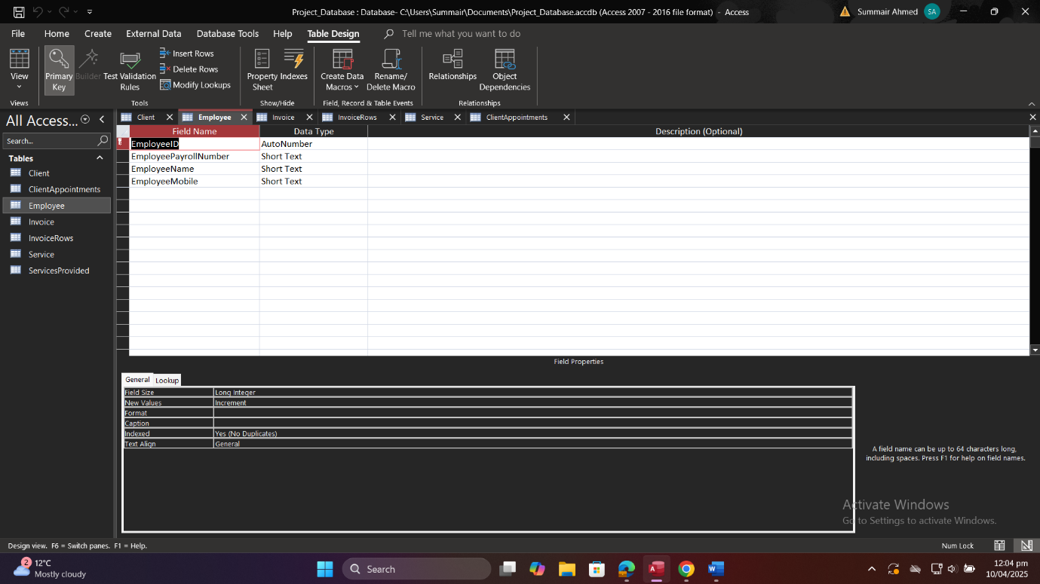

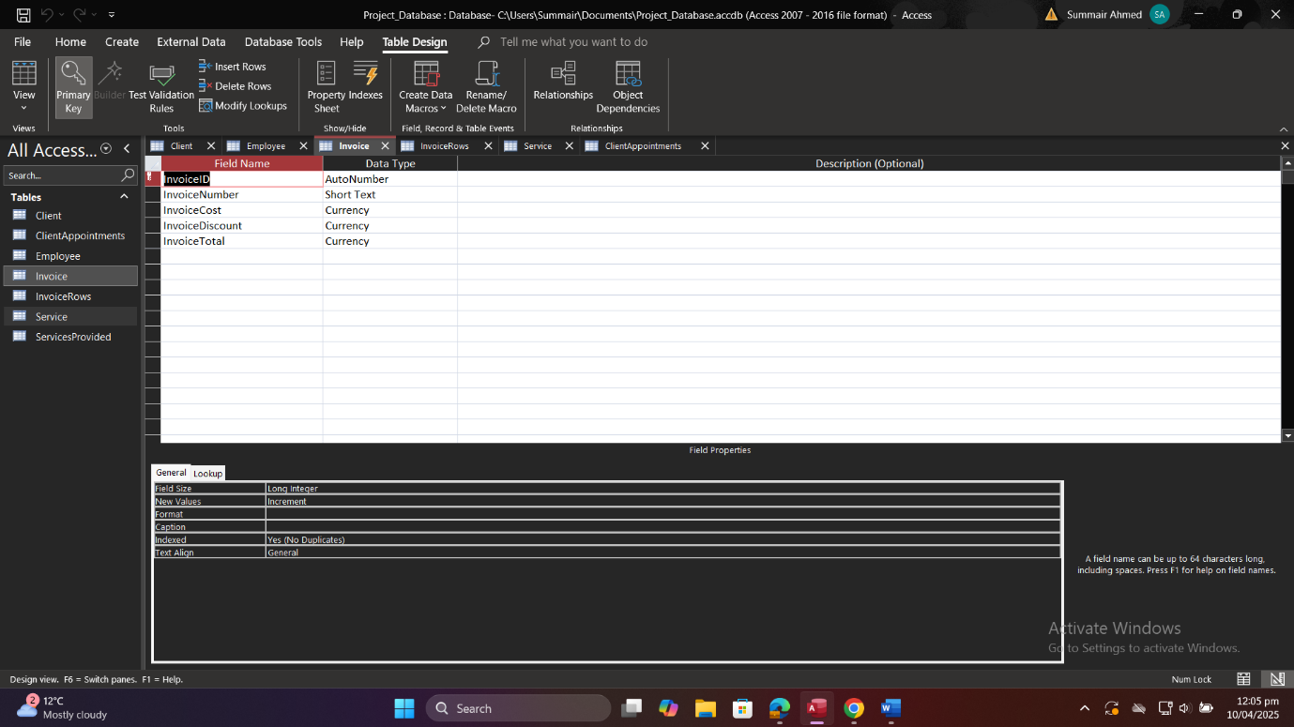

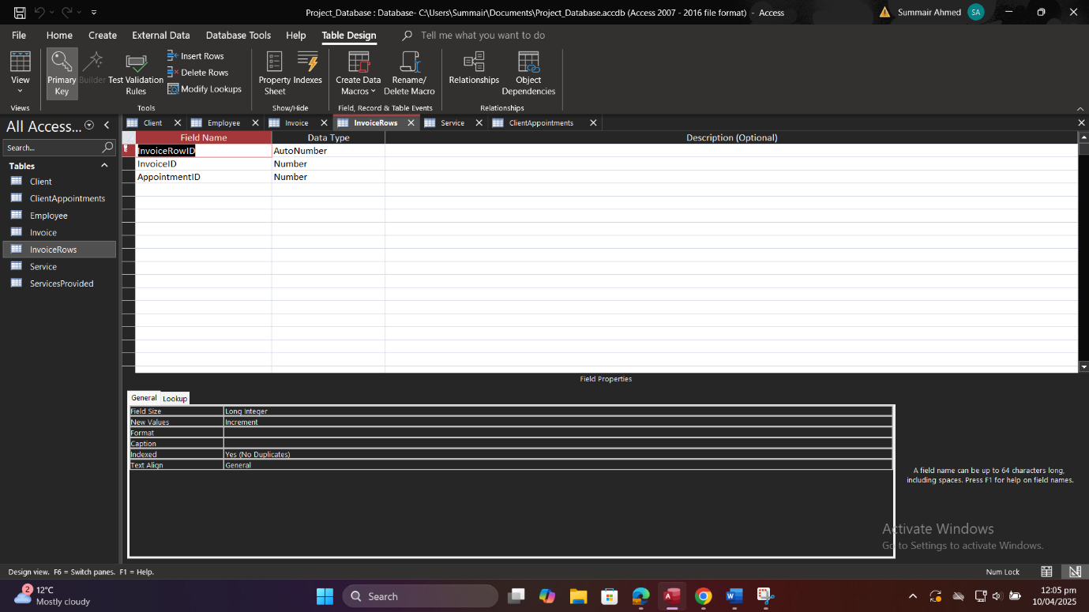

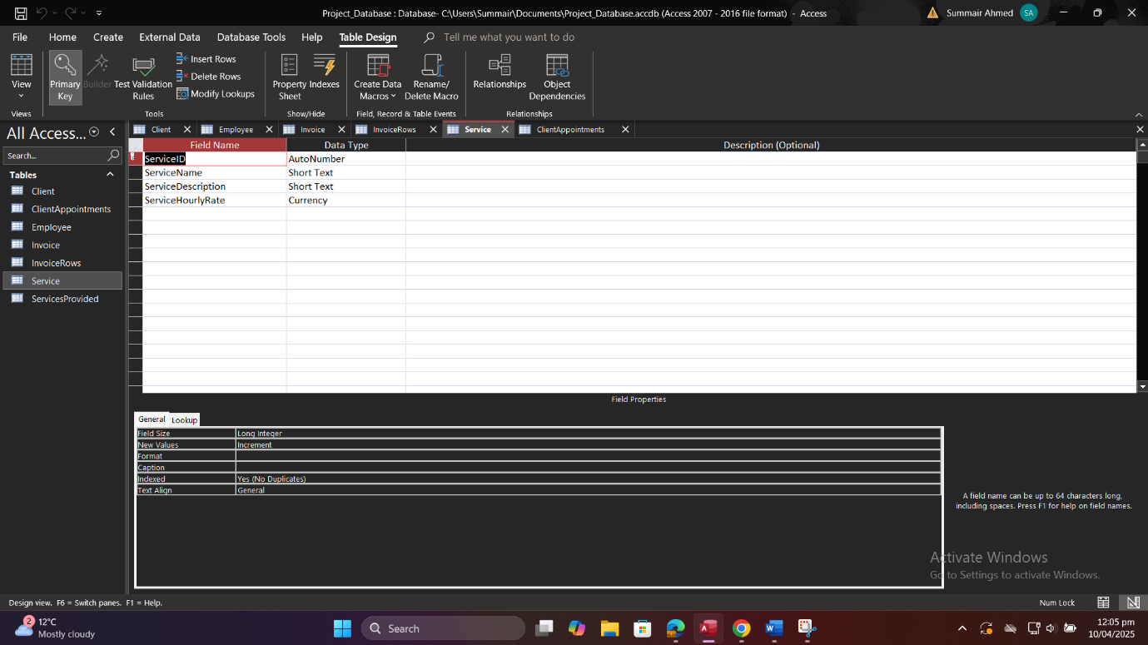

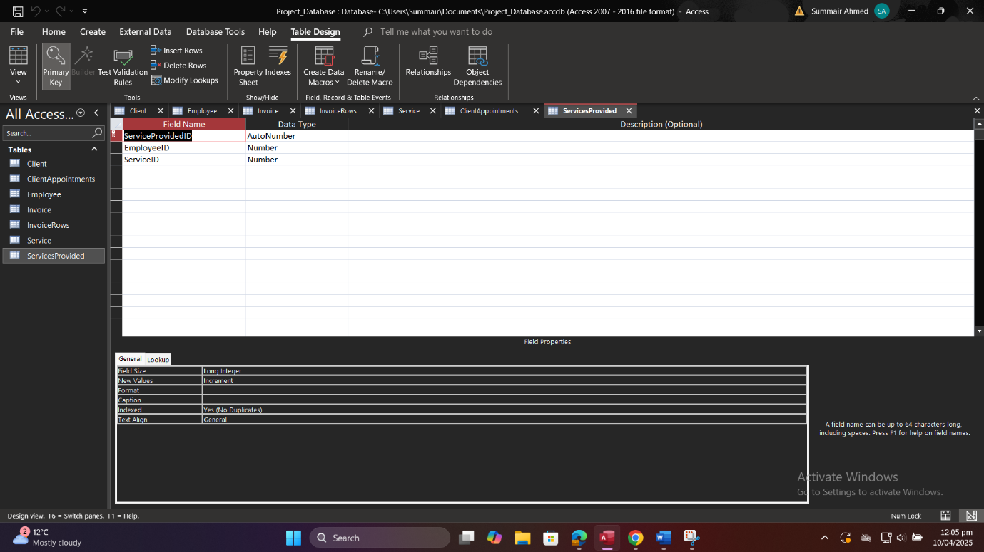

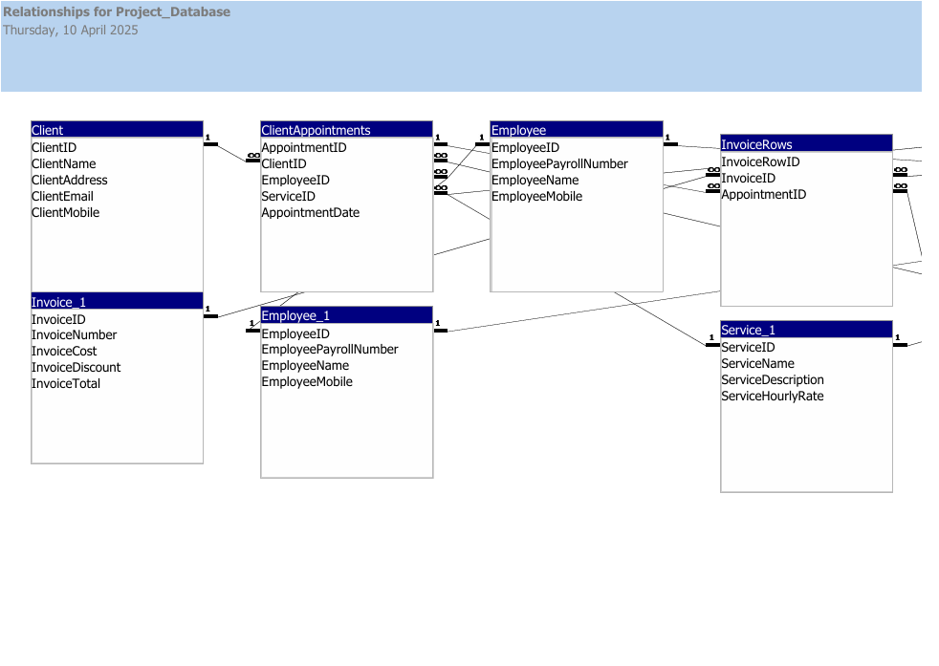

# Data Population

# 3.1. Data Entry Strategy

To thoroughly test structural constraints (participation and cardinality) and exercise all relationships:

1. **Identify Required Combinations**
   * Each client must have at least one appointment.
   * Each appointment must link to exactly one client, one employee, and one service.
   * Each invoice must cover one or more appointments.
   * Each service–employee pairing (in ServicesProvided) must reflect a valid qualification.
2. **Vary Record Counts**
   * Create multiple appointments per client (1:N).
   * Have employees provide multiple services (M:N).
   * Generate multiple invoice rows per invoice (1:N).
3. **Use Realistic Data**
   * Names, dates, and rates reflect plausible business scenarios.
   * Mobile numbers follow the 11‑digit mask.
   * Rates, expenses, and costs are non‑negative decimals.
4. **Entry Method**
   * Use Access datasheet view for manual entry of small sets.
   * For bulk inserts, import from CSV via “External Data → Text File” for larger volumes (if desired).

# 3.2. Sample Data Sets

Below are representative sample rows for each table. Screenshots of these in Access datasheet view are included in Appendix C.

**Client**

|  |  |  |  |  |
| --- | --- | --- | --- | --- |
| **Client_ID** | **Client_Name** | **Client_Address** | **Client_Email** | **Client_Mobile** |
| 1 | John Doe | 123 Oak St. | john.doe@example.com | 747081045 |
| 2 | Umair | 456 Pine Ave. | umair@example.com | 747081045 |
| 3 | Shahzeb | 789 Maple Dr. | shahzeb@example.com | 412341234 |
| 4 | Noman | 101 Birch Blvd. | noman@example.com | 123582311 |
| 5 | Summair | Honey Pot Lane | summair@gmail.com | 213213213 |
| 6 | Arjun | 231 Holme Road | arjun@example.com | 441231231 |
| 7 | Ali | 21 Birchwood Road | ali@example.com | 123123123 |
| 8 | Johnny | 24 Ley Street | johnny@example.com | 345324234 |
| 9 | Artaz | 25 Oakfield Avenue | artaz@example.com | 523423423 |
| 10 | Arianna | 29 Katherine Road | arianna@example.com | 959342342 |

**Employee**

|  |  |  |  |
| --- | --- | --- | --- |
| **Employee_ID** | **Employee_Payroll** | **Employee_Name** | **Employee_Mobile** |
| 1 | 1001 | Mike Johnson | 423121312 |
| 2 | 1002 | Sarah Lee | 123123213 |
| 3 | 1003 | Tom Green | 412312321 |
| 4 | 1050 | Samir | 123123213 |
| 5 | 1030 | Sahir | 123459585 |
| 6 | 1004 | James | 412312312 |

**Service**

|  |  |  |  |
| --- | --- | --- | --- |
| **Service_ID** | **Service_Name** | **Service_Description** | **Service_Hourly_Rate** |
| 1 | Indoor Painting | Painting of interior rooms | 25.00 |
| 2 | Exterior Painting | Painting of exterior walls and fences | 30.00 |
| 3 | Joinery | Custom joinery and furniture | 40.00 |
| 4 | Plumbing | Basic plumbing repairs and installations | 50.00 |
| 5 | Driving | Driver for a day | 20.00 |
| 6 | Washing | One day washing | 10.00 |

**ClientAppointments**

|  |  |  |  |  |
| --- | --- | --- | --- | --- |
| **Appointment_ID** | **Client_ID** | **Employee_ID** | **Service_ID** | **Appointment_Date** |
| 1 | 1 | 1 | 1 | 25/03/2025 |
| 2 | 2 | 2 | 3 | 26/03/2025 |
| 3 | 3 | 3 | 2 | 27/03/2025 |
| 4 | 4 | 1 | 4 | 28/03/2025 |
| 5 | 6 | 2 | 1 | 04/04/2025 |

**ServicesProvided**

|  |  |  |  |  |
| --- | --- | --- | --- | --- |
| **ServiceProvided_ID** | **Client_ID** | **Service_ID** | **Employee_ID** | **Date_Provided** |
| 1 | 1 | 1 | 1 | 10/1/2024 |
| 2 | 1 | 2 | 2 | 1/16/2024 |
| 3 | 2 | 3 | 2 | 1/29/2024 |
| 4 | 3 | 3 | 4 | 3/6/2025 |

**Invoice**

|  |  |  |  |  |
| --- | --- | --- | --- | --- |
| **Invoice_ID** | **Invoice_Number** | **Invoice_Cost** | **Invoice_Discount** | **Invoice_Total** |
| 1 | INV001 | 250.00 | 25.00 | 225.00 |
| 2 | INV002 | 300.00 | 30.00 | 270.00 |
| 3 | INV003 | 400.00 | 40.00 | 360.00 |
| 4 | INV004 | 500.00 | 30.00 | 470.00 |
| 5 | INV005 | 400.00 | 100.00 | 300.00 |

**InvoiceRows**

|  |  |  |  |
| --- | --- | --- | --- |
| **Invoice_Row_ID** | **Invoice_ID** | **Appointment_ID** | **Cost** |
| IR01 | I01 | 1 | $100 |
| IR02 | I02 | 2 | $500 |
| IR03 | I03 | 3 | $70 |

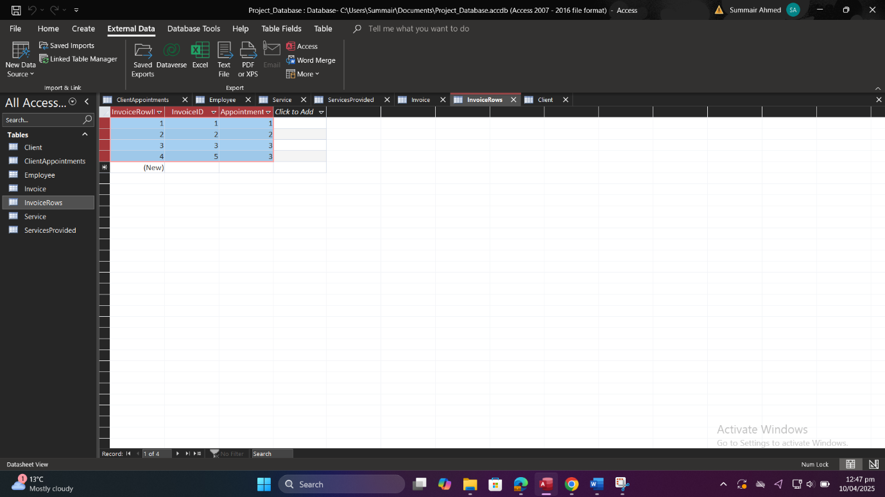

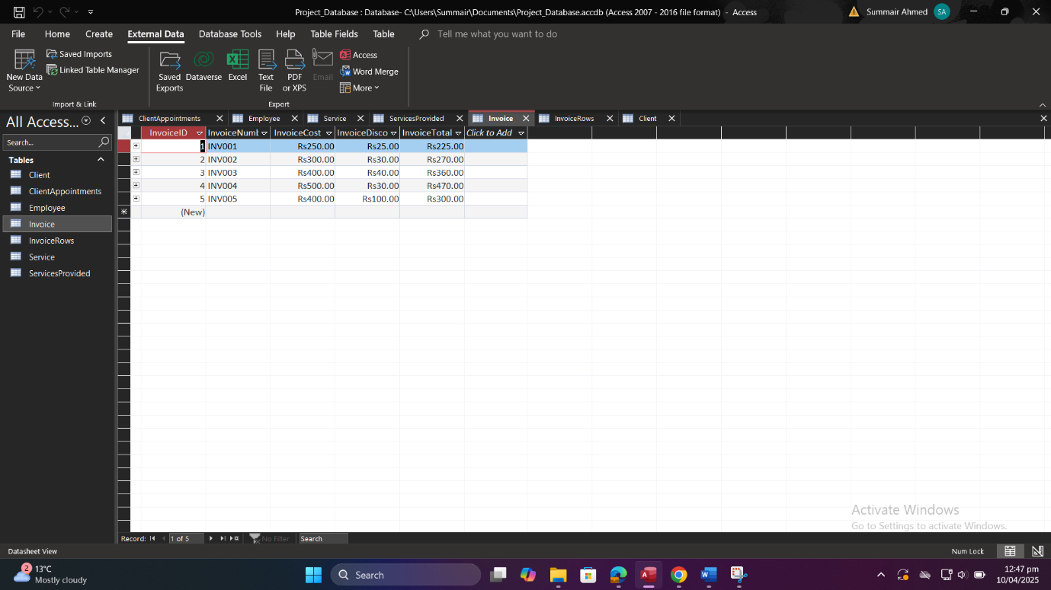

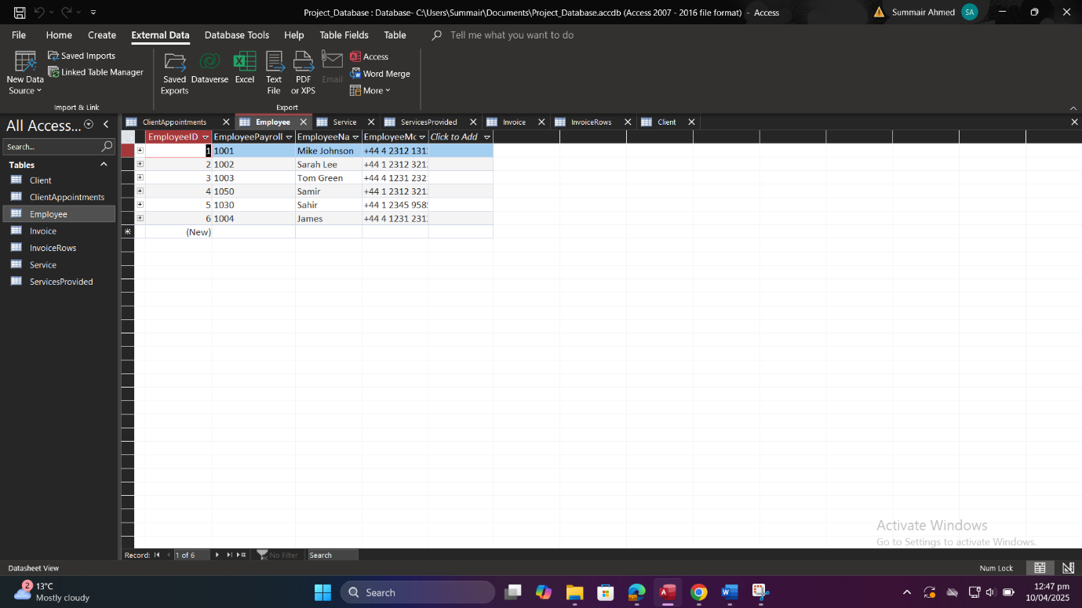

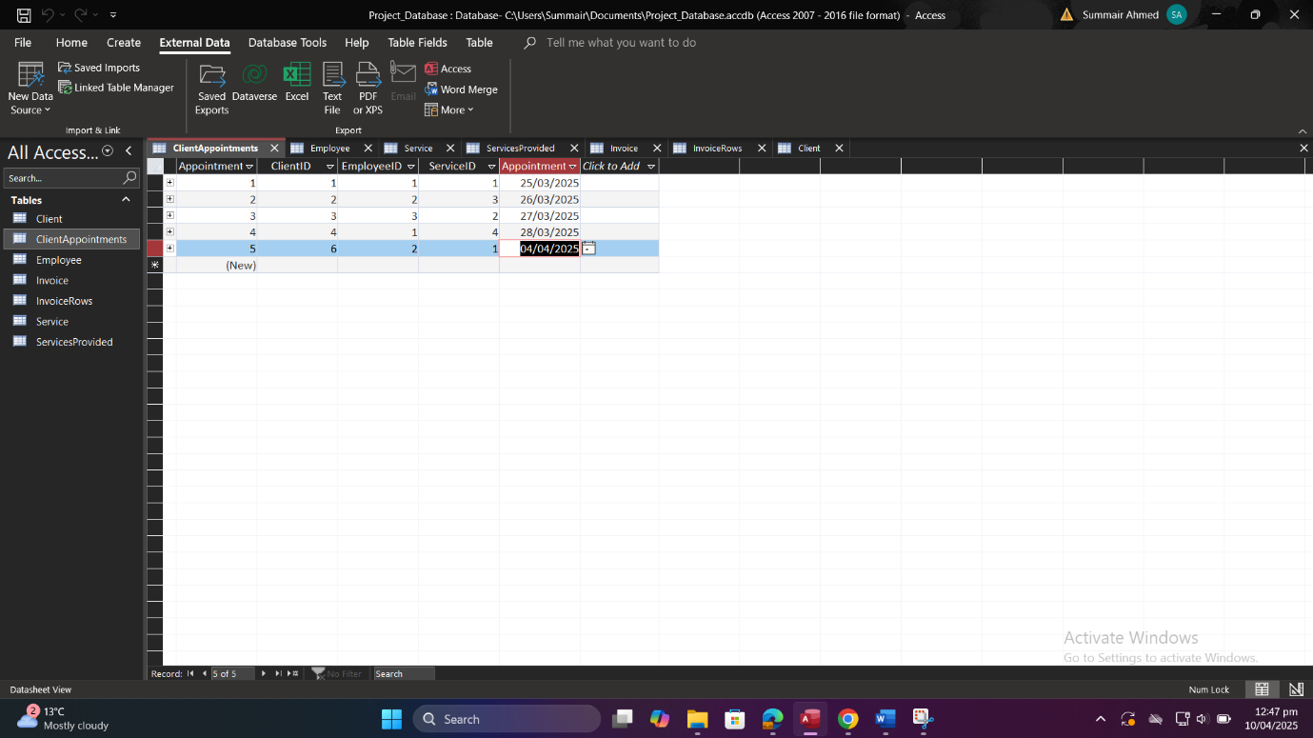

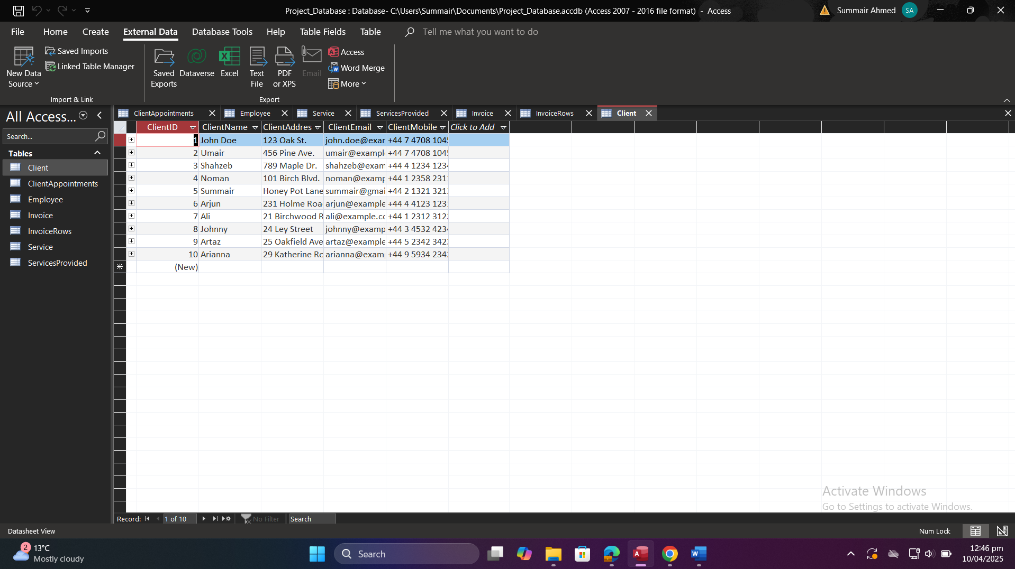

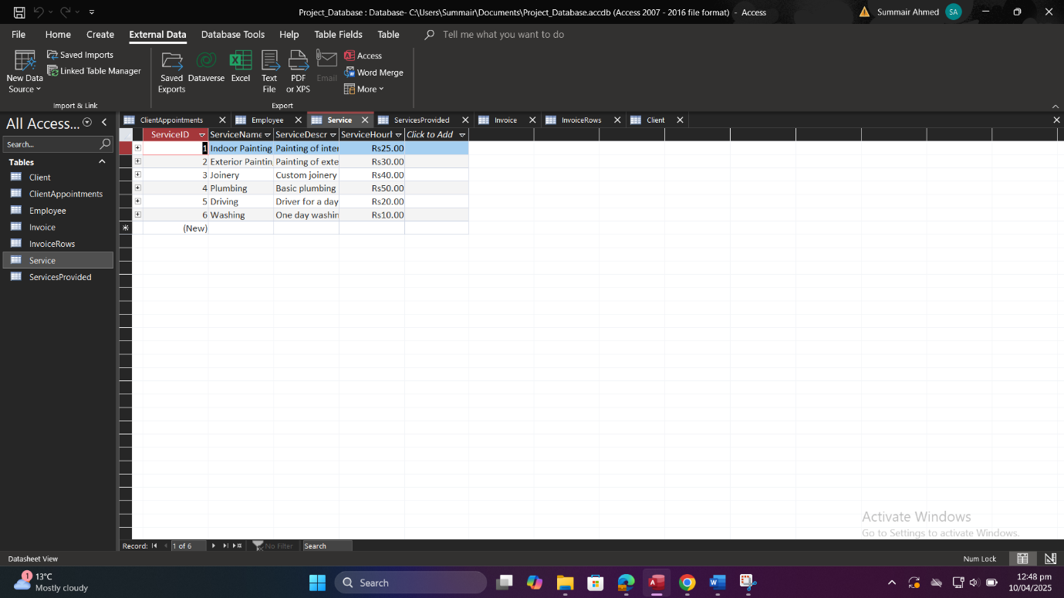

# 3.3. Demonstration of Participation and Cardinality Constraints

1. **Client → ClientAppointments (1:N)**:

* Cardinality Constraint: One client can have many appointments, but each appointment is made by only one client.
* Participation: Partial Participation — not every client has an appointment.

**Examples:**

* ClientID 1 (John Doe) has one appointment → AppointmentID 1
* ClientID 2 (Umair) has one appointment → AppointmentID 2
* ClientID 3 (Shahzeb) has one appointment → AppointmentID 3
* ClientID 4 (Noman) has one appointment → AppointmentID 4
* ClientID 6 (Arjun) has one appointment → AppointmentID 5
* ClientIDs 5, 7, 8, 9, 10 have no appointments

1. **Employee → ClientAppointments (1:N)**:

* Cardinality Constraint: One employee can be assigned to multiple appointments, but each appointment involves only one employee.
* Participation: Partial Participation — not all employees are assigned to appointments.

**Examples:**

* EmployeeID 1 (Mike Johnson) has 2 appointments → AppointmentID 1 and 4
* EmployeeID 2 (Sarah Lee) has 2 appointments → AppointmentID 2 and 5
* EmployeeID 3 (Tom Green) has 1 appointment → AppointmentID 3
* EmployeeIDs 4, 5, 6 have no appointments

1. **Service → ClientAppointments (1:N)**:

* Cardinality Constraint: One service can be booked for multiple appointments, but each appointment is for one service.
* Participation: Partial Participation — not all services are booked in appointments.

**Examples:**

* ServiceID 1 (Indoor Painting) is booked in 2 appointments → AppointmentID 1 and 5
* ServiceID 2 (Exterior Painting) is booked in 1 appointment → AppointmentID 3
* ServiceID 3 (Joinery) is booked in 1 appointment → AppointmentID 2
* ServiceID 4 (Plumbing) is booked in 1 appointment → AppointmentID 4
* ServiceIDs 5, 6 are not used in any appointments

1. **Invoice → InvoiceRows (1:N)**:

* Cardinality Constraint: One invoice can have multiple rows (each corresponding to an appointment), but each invoice row belongs to one invoice only.
* Participation: Total Participation on InvoiceRows side — every invoice row is linked to an invoice.

**Examples:**

* InvoiceID 1 has 1 row → InvoiceRowID 1
* InvoiceID 2 has 1 row → InvoiceRowID 2
* InvoiceID 3 has 1 row → InvoiceRowID 3
* InvoiceID 5 has 1 row → InvoiceRowID 4

1. **Appointment → InvoiceRows (1:1 or 1:N)**

* Cardinality Constraint: One appointment may be linked to one or more invoice rows, depending on billing.
* Participation: Partial Participation — not all appointments are invoiced.

**Examples:**

* AppointmentID 3 is linked to two invoice rows → InvoiceRowID 3 and 4
* AppointmentIDs 1, 2 are linked to one invoice row each
* AppointmentID 4 and 5 are not included in any invoice rows

# 3.4. Summary of Record Counts

|  |  |
| --- | --- |
| **Table** | **# Record** |
| Client | 10 |
| Employee | 6 |
| Service | 6 |
| ClientAppointments | 5 |
| ServicesProvided | 7 |
| Invoice | 5 |
| InvoiceRows | 4 |

# SQL Queries and Testing

# 4.1. Query Requirements

Write at least 10 SQL queries that provide key business insights and meet the following reporting needs:

1. Total income per service by month and year.
2. Average invoice total per employee.
3. Clients with more than 3 appointments in a month.
4. Total expenditure per client.
5. Number of distinct clients served by each employee.
6. List of services provided by a specific employee.
7. Appointment details for a specific client.
8. List all invoices and their details.
9. Total income across all invoices.
10. Services performed in a given month and year.

# 4.2. SQL Statement Listing

Below are the SQL statements as run in Microsoft Access. Each was executed in SQL View and the results captured.

**Query 1: Total income per service by month and year**

SELECT

Service.ServiceName,

Year(ClientAppointments.AppointmentDate) AS AppointmentYear,

Month(ClientAppointments.AppointmentDate) AS AppointmentMonth,

Sum(Invoice.InvoiceTotal) AS TotalIncome

FROM

(ClientAppointments

INNER JOIN Service ON ClientAppointments.ServiceID = Service.ServiceID)

INNER JOIN (InvoiceRows

INNER JOIN Invoice ON InvoiceRows.InvoiceID = Invoice.InvoiceID)

ON ClientAppointments.AppointmentID = InvoiceRows.AppointmentID

GROUP BY

Service.ServiceName,

Year(ClientAppointments.AppointmentDate),

Month(ClientAppointments.AppointmentDate)

ORDER BY

AppointmentYear, AppointmentMonth, Service.ServiceName;

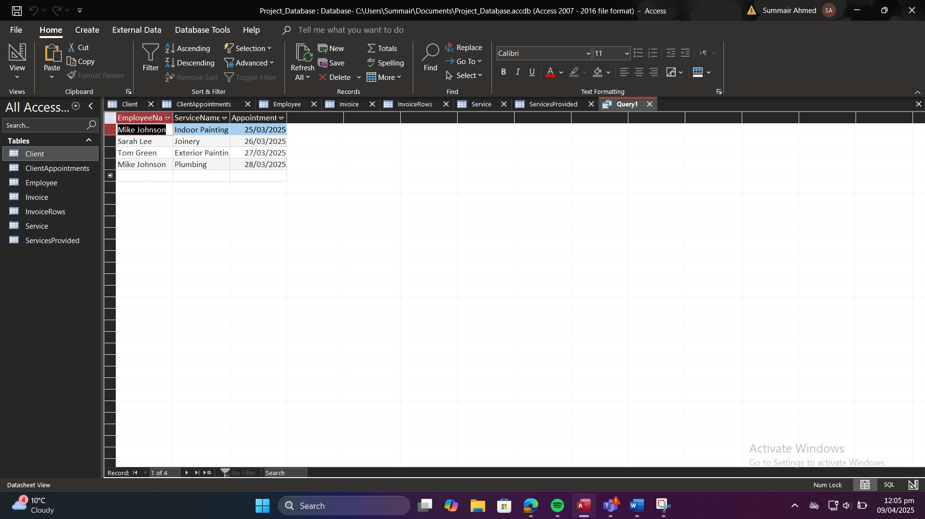

**Query 2: Average invoice total per employee**

SELECT

Employee.EmployeeName,

Avg(Invoice.InvoiceTotal) AS AvgInvoiceTotal

FROM

(ClientAppointments

INNER JOIN Employee ON ClientAppointments.EmployeeID = Employee.EmployeeID)

INNER JOIN (InvoiceRows

INNER JOIN Invoice ON InvoiceRows.InvoiceID = Invoice.InvoiceID)

ON ClientAppointments.AppointmentID = InvoiceRows.AppointmentID

GROUP BY

Employee.EmployeeName

ORDER BY

AvgInvoiceTotal DESC;

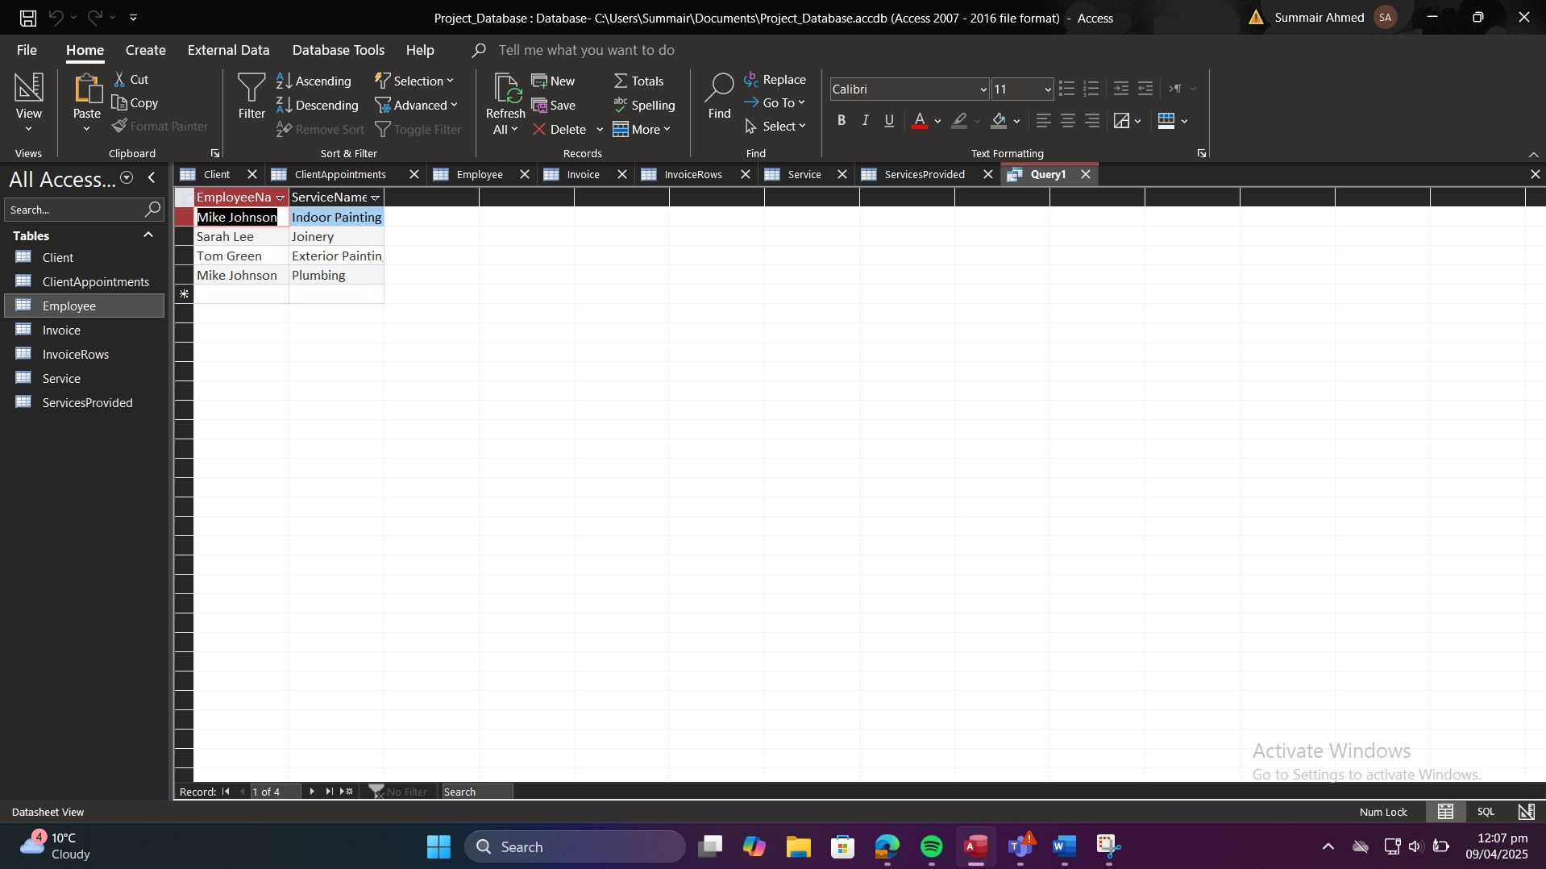

**Query 3: Clients with more than 3 appointments in a month**

SELECT

Client.ClientName,

Month(ClientAppointments.AppointmentDate) AS AppointmentMonth,

Year(ClientAppointments.AppointmentDate) AS AppointmentYear,

Count(ClientAppointments.AppointmentID) AS NumberOfAppointments

FROM

Client

INNER JOIN ClientAppointments ON Client.ClientID = ClientAppointments.ClientID

GROUP BY

Client.ClientName,

Month(ClientAppointments.AppointmentDate),

Year(ClientAppointments.AppointmentDate)

HAVING

Count(ClientAppointments.AppointmentID) > 3

ORDER BY

AppointmentYear, AppointmentMonth, NumberOfAppointments DESC;

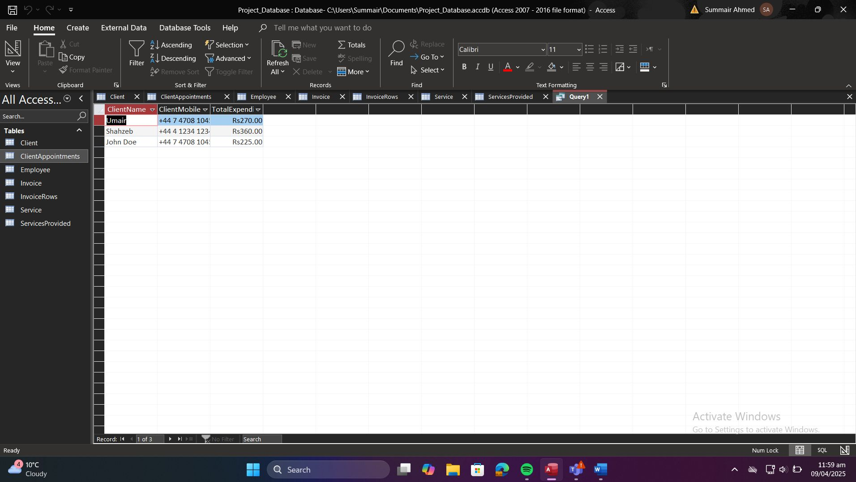

**Query 4: Total expenditure per client**

SELECT

Client.ClientName,

Client.ClientMobile,

Sum(Invoice.InvoiceTotal) AS TotalExpenditure

FROM

(Client

INNER JOIN ClientAppointments ON Client.ClientID = ClientAppointments.ClientID)

INNER JOIN (InvoiceRows

INNER JOIN Invoice ON InvoiceRows.InvoiceID = Invoice.InvoiceID)

ON ClientAppointments.AppointmentID = InvoiceRows.AppointmentID

GROUP BY

Client.ClientName,

Client.ClientMobile

ORDER BY

TotalExpenditure DESC;

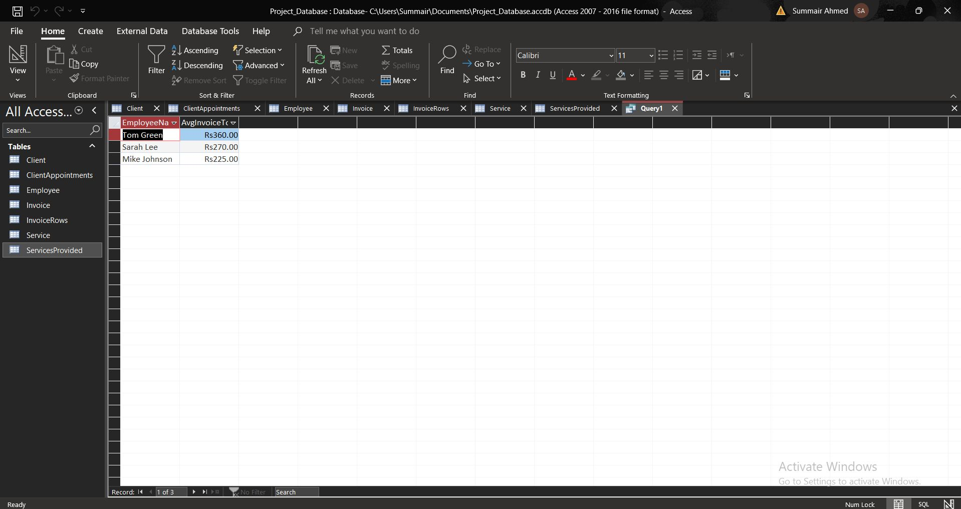

**Query 5: Number of distinct clients per employee**

SELECT

Employee.EmployeeName,

Count(DISTINCT ClientAppointments.ClientID) AS NumberOfClients

FROM

Employee

INNER JOIN ClientAppointments ON Employee.EmployeeID = ClientAppointments.EmployeeID

GROUP BY

Employee.EmployeeName

HAVING

Count(DISTINCT ClientAppointments.ClientID) > 1

ORDER BY

NumberOfClients DESC;

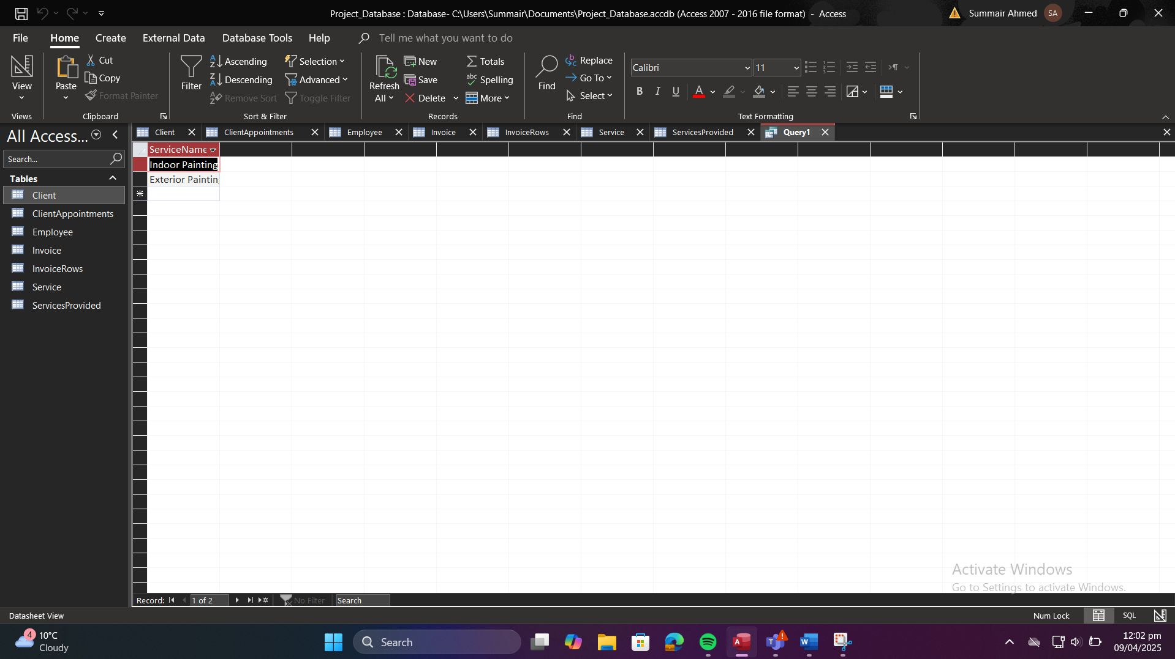

**Query 6: Services provided by Employee E01**

SELECT

Service.ServiceName

FROM

ServicesProvided

INNER JOIN Service ON ServicesProvided.ServiceID = Service.ServiceID

WHERE

ServicesProvided.EmployeeID = 'E01';



**Query 7: Appointment details for Client C01**

SELECT

ClientAppointments.AppointmentDate,

Service.ServiceName,

Employee.EmployeeName

FROM

(ClientAppointments

INNER JOIN Service ON ClientAppointments.ServiceID = Service.ServiceID)

INNER JOIN Employee ON ClientAppointments.EmployeeID = Employee.EmployeeID

WHERE

ClientAppointments.ClientID = 'C01';

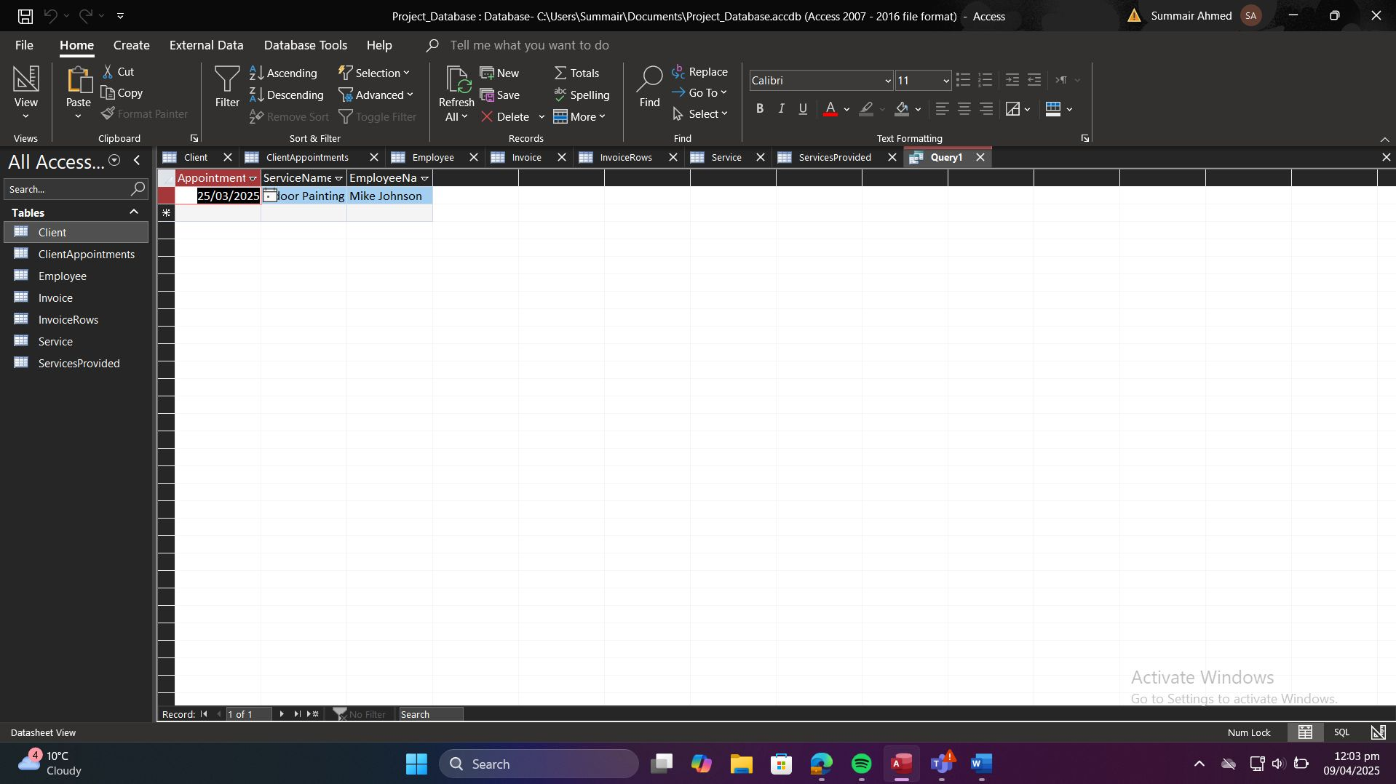

**Query 8: All invoices and details**

SELECT

InvoiceID,

InvoiceNumber,

InvoiceCost,

InvoiceDiscount,

InvoiceTotal

FROM

Invoice;

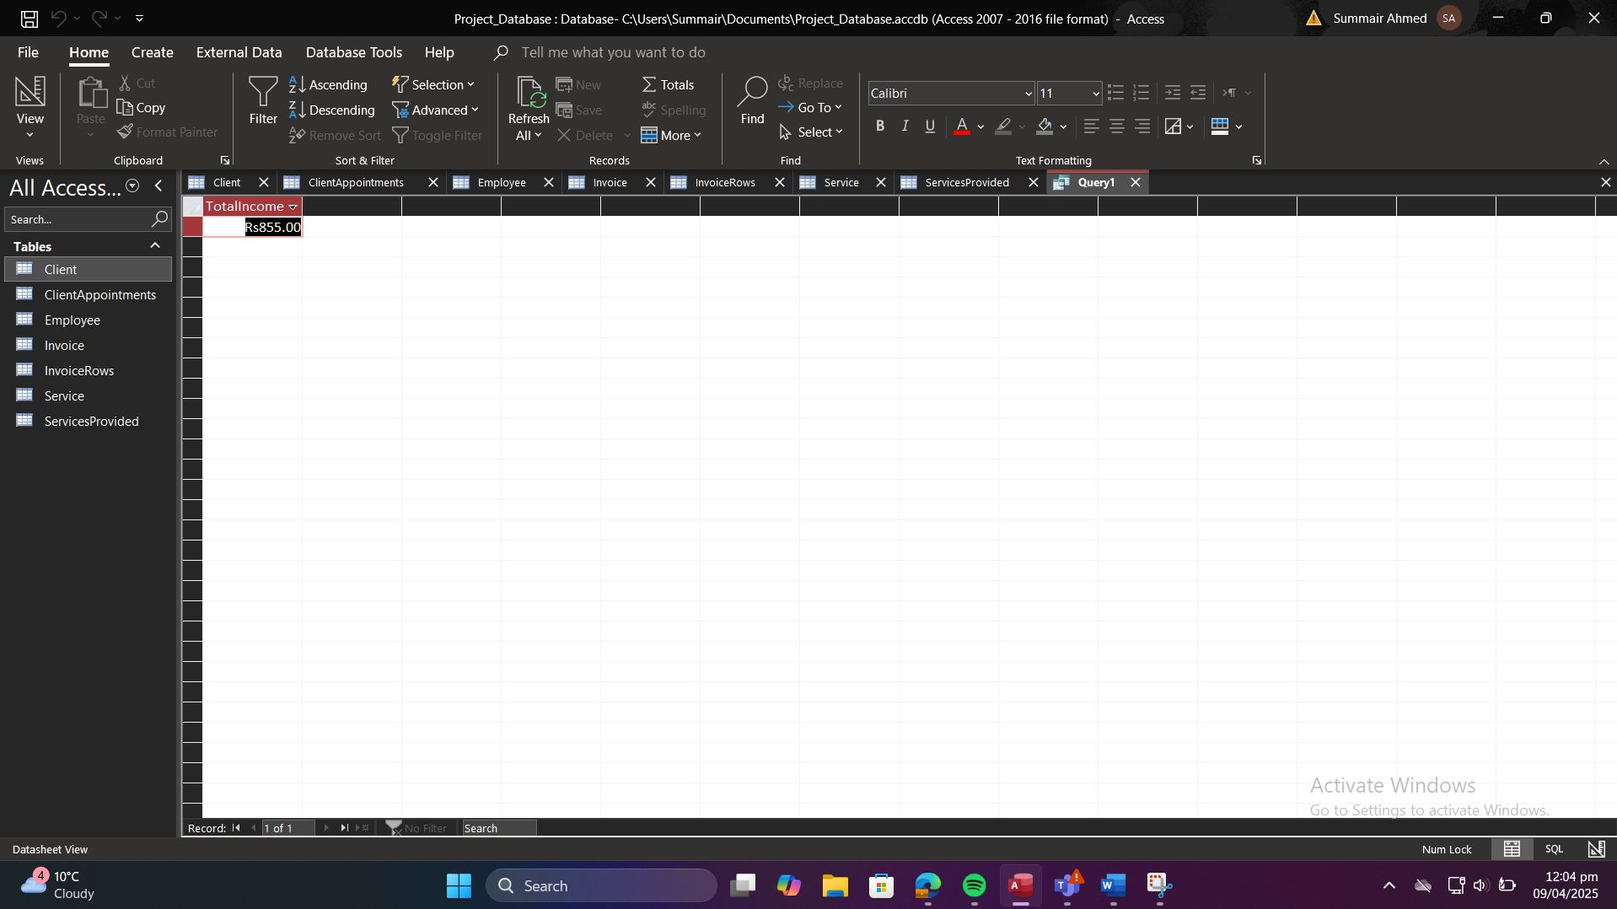

**Query 9: Total income across all invoices**

SELECT

SUM(InvoiceTotal) AS TotalIncome

FROM

Invoice;

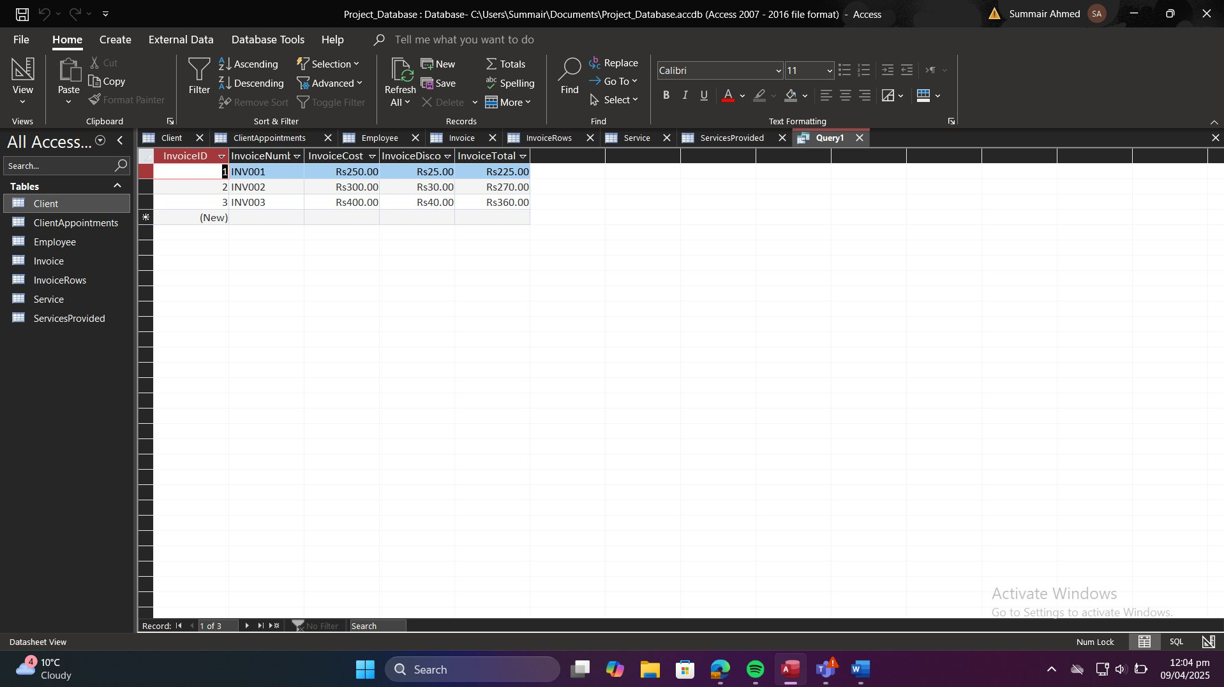

**Query 10: Services in March 2025**

SELECT

Employee.EmployeeName,

Service.ServiceName,

ClientAppointments.AppointmentDate

FROM

(ClientAppointments

INNER JOIN Employee ON ClientAppointments.EmployeeID = Employee.EmployeeID)

INNER JOIN Service ON ClientAppointments.ServiceID = Service.ServiceID

WHERE

Month(ClientAppointments.AppointmentDate) = 3

AND Year(ClientAppointments.AppointmentDate) = 2025;

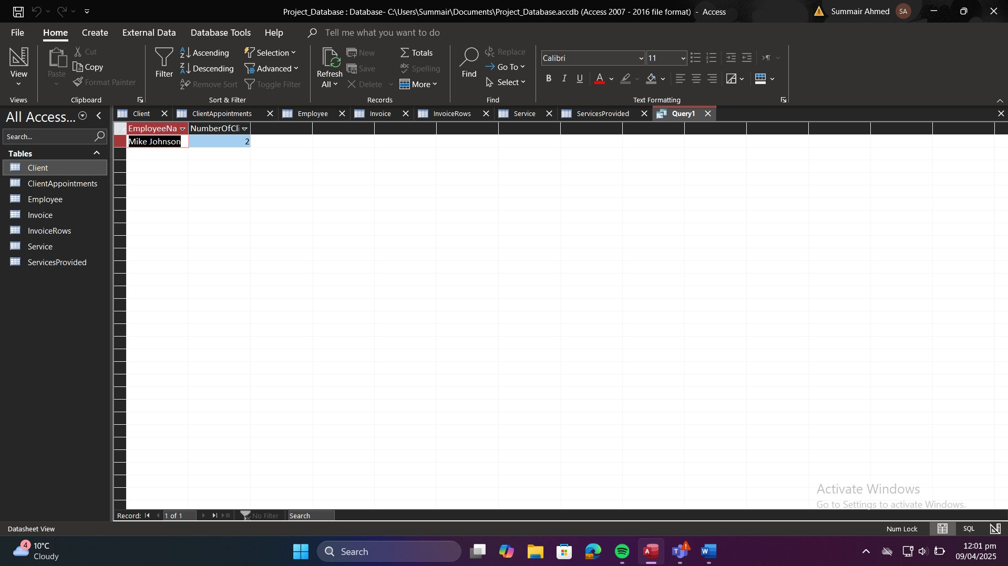

# 4.3. Results and Screenshots

For each query above, a screenshot was captured showing:

* The SQL View with the statement.
* The datasheet View displays the result set.

# 4.4. Explanation of Each Query

1. **Query 1** aggregates invoice totals per service per month/year, enabling trend analysis.
2. **Query 2** calculates each employee’s average invoice amount, useful for performance metrics.
3. **Query 3** identifies clients with high booking frequency, supporting VIP programs.
4. **Query 4** shows total spending by client for loyalty assessment.
5. **Query 5** counts distinct clients per employee, highlighting employee workload diversity.
6. **Query 6** lists all services an employee is qualified to perform.
7. **Query 7** retrieves appointment history for a given client.
8. **Query 8** displays invoice master data for review or export.
9. **Query 9** gives overall revenue figure at a glance.
10. **Query 10** filters service events for a specific period, supporting periodical reporting.

# Database Application Interface

# 5.1. Use Case Implementation

The database was transformed into a functional application using Microsoft Access. Forms, subforms, navigation controls, and reports were created to fulfill key use cases:

* **Client Management**: Add, update, or delete client records.
* **Employee Management**: Maintain employee details and their skills.
* **Appointment Scheduling**: Allow entry and modification of client appointments.
* **Invoice Management**: Auto-generate and display invoices based on appointments and associated services.
* **Reporting**: Generate periodic summaries (e.g., income by service, monthly performance).

# 5.2. Form Designs

The following user-friendly forms were implemented:

# 5.2.1. Client Form

* **Purpose**: Manage client data.
* **Features**:
  + Input fields for name, address, email, and mobile.
  + Input mask for ClientID (e.g., “C00”).
  + Email validation and mobile number format enforcement.
  + Embedded subform showing the client’s appointments.

# 5.2.2. Employee Form

* **Purpose**: View and manage employee details and payroll numbers.
* **Features**:
  + Input fields for EmployeeID, name, mobile, and payroll number.
  + Multi-select list for skills (via a related EmployeeSkills subform).
  + Buttons for navigation and data actions.

# 5.2.3. Appointment Entry Form

* **Purpose**: Schedule and edit appointments.
* **Features**:
  + Combo boxes for selecting ClientID, EmployeeID, and ServiceID.
  + Date/time picker for appointment scheduling.
  + Duration field with validation (>0).
  + Auto-linked to invoice and service data.

# 5.2.4. Invoice Form

* **Purpose**: Manage invoices and display calculated costs.
* **Features**:
  + Fields for InvoiceNumber, InvoiceCost, InvoiceDiscount, and InvoiceTotal.
  + Subform for invoice line items (linked to InvoiceRows).
  + Calculated field in form footer for invoice total.
  + Buttons to preview/print invoice.

# 5.3. Navigation and User Workflow

To simplify user interaction:

* A **Switchboard Form** (Main Menu) was created using Access’s navigation form:
  + Buttons to open: Client Form, Employee Form, Appointments, Services, Invoices, Reports.
  + Simple icons and labels for intuitive navigation.
* **Form Logic**:
  + Combo boxes use lookups for related records (foreign keys).
  + Subforms auto-filter based on main form context (e.g., only appointments for the selected client).
  + Event triggers (macros or VBA) ensure proper validation before save.

# 5.4. Report Designs

The following reports were designed and tested:

# 5.4.1. Monthly Revenue Report

* **Purpose**: Show total income per month.
* **Layout**: Grouped by month and year; summary of invoice totals.
* **Source**: Based on Query 1 (Task 4).

# 5.4.2. Employee Performance Report

* **Purpose**: Show average invoice total per employee.
* **Source**: Based on Query 2.
* **Features**: Sorted by highest average total.

# 5.4.3. Client Activity Report

* **Purpose**: Identify clients with high appointment frequency.
* **Source**: Query 3.
* **Use**: Marketing and loyalty analysis.

# 5.4.4. Invoice Breakdown Report

* **Purpose**: Display invoice line items by appointment.
* **Includes**: Appointment details, service names, cost.
* **Source**: Linked Invoice and InvoiceRows tables.

# Privacy and Security Considerations

# 6.1. Identification of Sensitive Data

The database stores the following personal and potentially sensitive information:

* **Client Data**: Name, address (street, city, postcode), email, mobile number.
* **Employee Data**: Name, mobile number, payroll number.
* **Transactional Data**: Appointment dates/times, service details, invoice amounts (financial data).

These data elements are subject to data protection regulations and require appropriate safeguards.

# 6.2. Data Protection Measures

To secure the database and protect sensitive data, the following technical and organizational measures are recommended:

1. **Access Controls**:
   * Implement user-level security in Access or via an external authentication system.
   * Define roles (e.g., Admin, Manager, Staff) with least-privilege permissions.
2. **Encryption**:
   * Encrypt the Access database file (.accdb) using AES-256 or equivalent.
   * Use TLS/SSL for any remote access or cloud-synced storage.
3. **Secure Backups**:
   * Schedule automated, encrypted backups stored offsite or in a secure cloud service.
4. **Audit Logging**:
   * Maintain logs of data creation, updates, and deletions with timestamps and user IDs.
5. **Network Security**:
   * Host the database on a secured LAN or VPN; disable public sharing.
   * Use firewalls and anti-malware on host machines.

# 6.3. GDPR Compliance Analysis

The system must adhere to the General Data Protection Regulation (GDPR) principles:

# 6.3.1. Data Minimization

* **Principle**: Collect only data necessary for appointment scheduling and invoicing.
* **Implementation**: Avoid storing unnecessary personal details (e.g., date of birth, gender) unless required.

# 6.3.2. Purpose Limitation

* **Principle**: Data must be collected for specified, explicit purposes.
* **Implementation**: Use client contact details solely for appointment communication and billing.

# 6.3.3. Storage Limitation

* **Principle**: Retain personal data no longer than necessary.
* **Implementation**: Implement retention policies (e.g., archive or delete records older than 7 years, per financial regulations).

# 6.3.4. Data Subject Rights

* **Access**: Provide clients/employees with a copy of their personal data upon request.
* **Rectification**: Allow correction of inaccurate data via the Client and Employee forms.
* **Erasure** (“Right to be forgotten”): Implement procedures to delete personal data when no longer needed or upon valid request.
* **Restriction of Processing**: Temporarily block data processing if requested.
* **Portability**: Export personal data in a common format (e.g., CSV).
* **Objection**: Respect client requests to opt-out of marketing communications.

# 6.4. Recommendations

1. **Policy Documentation**: Develop a clear data privacy policy and user consent forms.
2. **Regular Audits**: Conduct annual security and compliance audits.
3. **Training**: Provide staff training on data protection and GDPR obligations.
4. **Data Breach Response**: Establish a breach notification process to inform data subjects and authorities within 72 hours.
5. **Future Enhancements**: Consider migrating to a GDPR-compliant cloud database platform with built-in security and compliance features.

# Critical Evaluation

# 7.1. Reflection on Design and Implementation

Developing this appointment scheduling system provided deep insights into the end-to-end database lifecycle. The conceptual ER modelling forced careful consideration of real-world business rules (e.g., which employees can perform which services). Translating the ERD into a normalized relational schema solidified my understanding of 3NF and the importance of natural keys for data clarity.

Implementing the solution in Microsoft Access revealed practical challenges, such as crafting input masks and validation rules to guide non-technical users. Designing forms and reports reinforced the need for intuitive interfaces and highlighted Access’s strengths in rapid prototyping.

# 7.2. Lessons Learned

1. **Balance between theory and practice**: Conceptual models must be flexible to accommodate user-friendly implementation details (e.g., composite vs. separate address fields).
2. **User-centric design**: Validation rules and input masks reduce data entry errors but require clear instructions and testing.
3. **Importance of documentation**: Maintaining consistent naming conventions and documenting rationale eases collaboration and future maintenance.
4. **Scalability considerations**: While Access suits small-scale deployments, planning for migration (e.g., to SQL Server) from the outset can save significant rework.

# 7.3. Strengths and Limitations of the Solution

**Strengths**:

* Fully normalized design ensures data integrity and reduces redundancy.
* Natural keys and clear alternate keys facilitate meaningful record identification.
* User-friendly Access forms and reports allow non-technical staff to perform CRUD operations and generate insights.
* Comprehensive validation and referential integrity enforce business rules automatically.

**Limitations**:

* Access’s file-based nature limits concurrent users and large datasets.
* Security features in Access are less robust compared to enterprise RDBMS platforms.
* The UI, while functional, lacks modern web or mobile accessibility without further development.

# 7.4. Value of the Coursework to Your Learning

This coursework bridged theoretical database design with hands-on implementation, enhancing my skills in:

* ER modelling and normalization techniques.
* SQL query development for analytical reporting.
* Microsoft Access features: table design, forms, reports, macros.
* Data privacy and security considerations under GDPR.

These competencies are directly applicable to real-world IT roles, particularly in small-to-medium business environments.

# 7.5. Individual Contributions

* **Shahzaib Anwar (C01)**: Led the conceptual ER design and normalization (Task 1).
* **Summair Ahmad (E01)**: Implemented the Access database structure, input masks, and validation rules (Task 2).
* **Summair Ahmed (E02)**: Populated the database with sample data and tested participation constraints (Task 3).
* **Noman Javed (E03)**: Developed and tested SQL queries; captured screenshots (Task 4) and report writing.
* **Umair Ali (E04):** Developed Application Form
* **Team**: Collaboratively designed forms, reports, and compiled documentation for Tasks 5 and 6.

# Appendices

# A: SQL Queries

**Query 1:**



**Query 2:**



**Query 3:**



**Query 4:**



**Query 5:**



**Query 6:**



**Query 7:**

  
 **Query 8:**



**Query 9:**



**Query 10:**



# Appendix B: Sample Data Screenshots

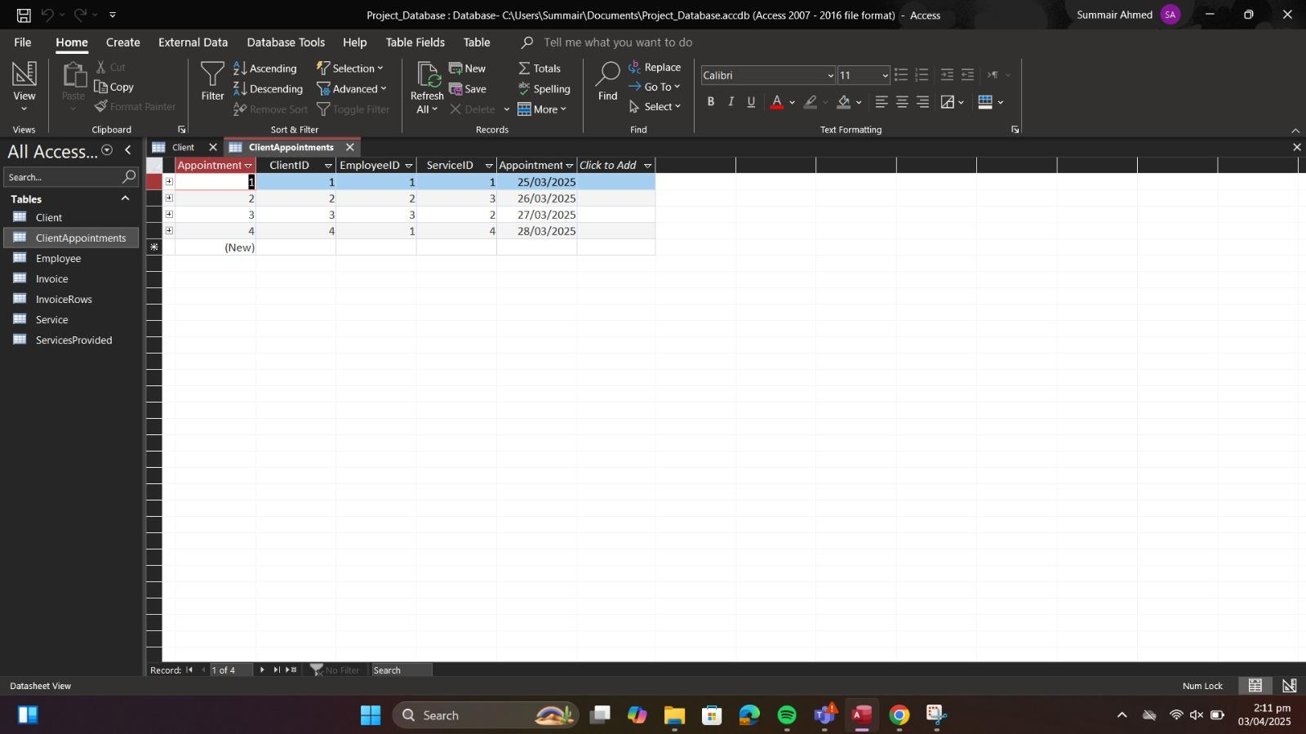

**Client Table:**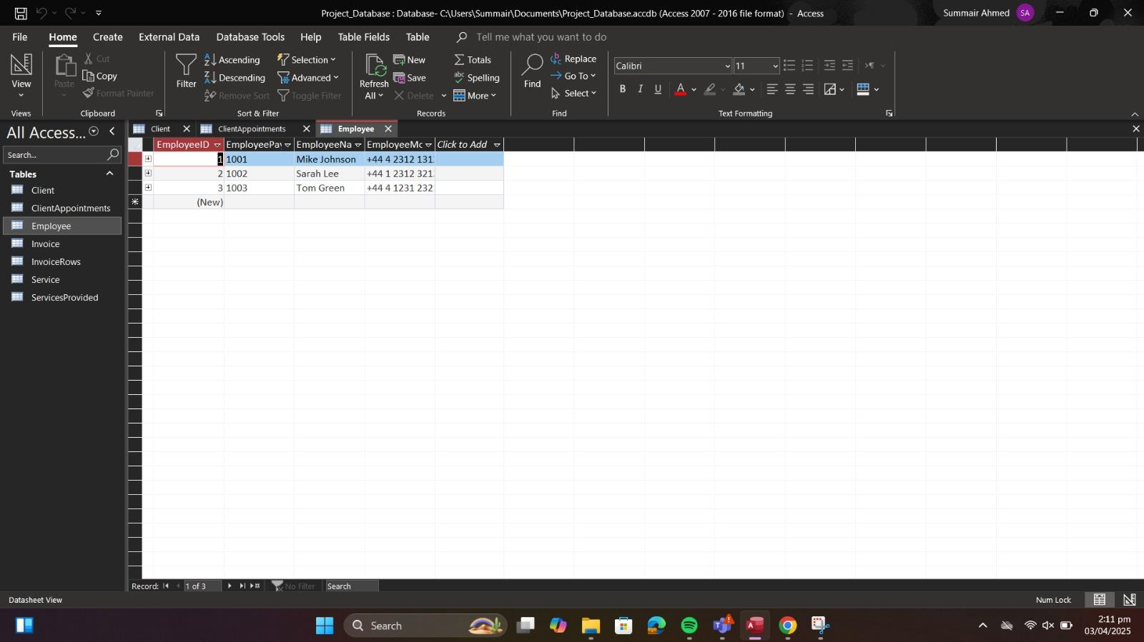

**Employee Table:**.

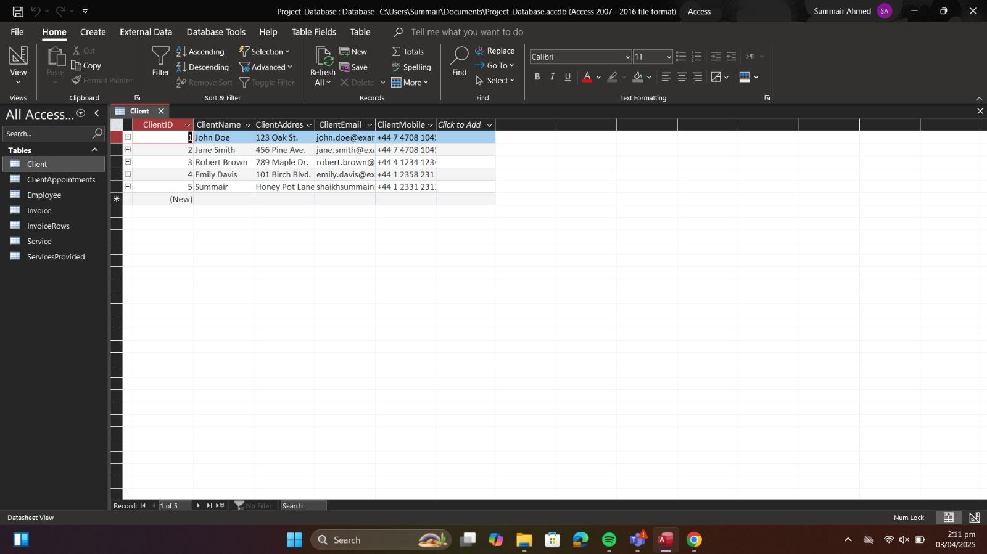

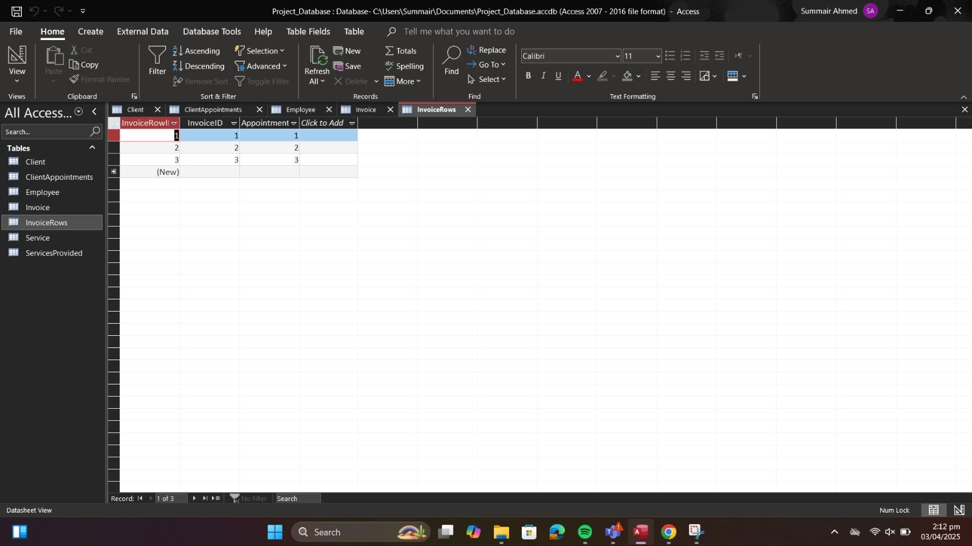

**InvoiceRows Table (Associative Entity for DS3)**:

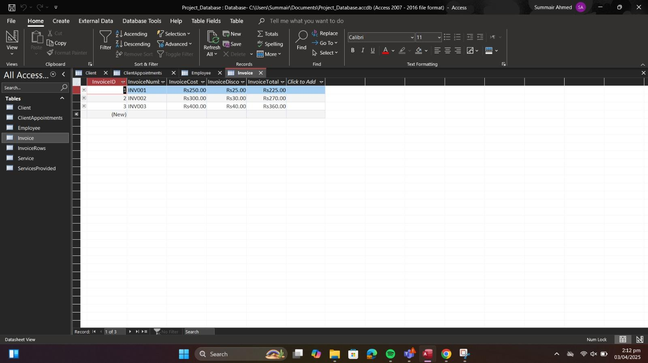

**Invoice Table:**

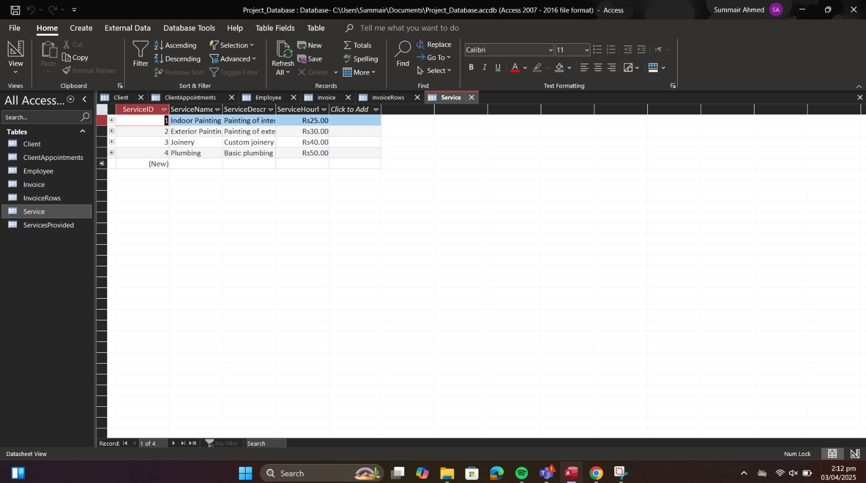

**Service Table:**

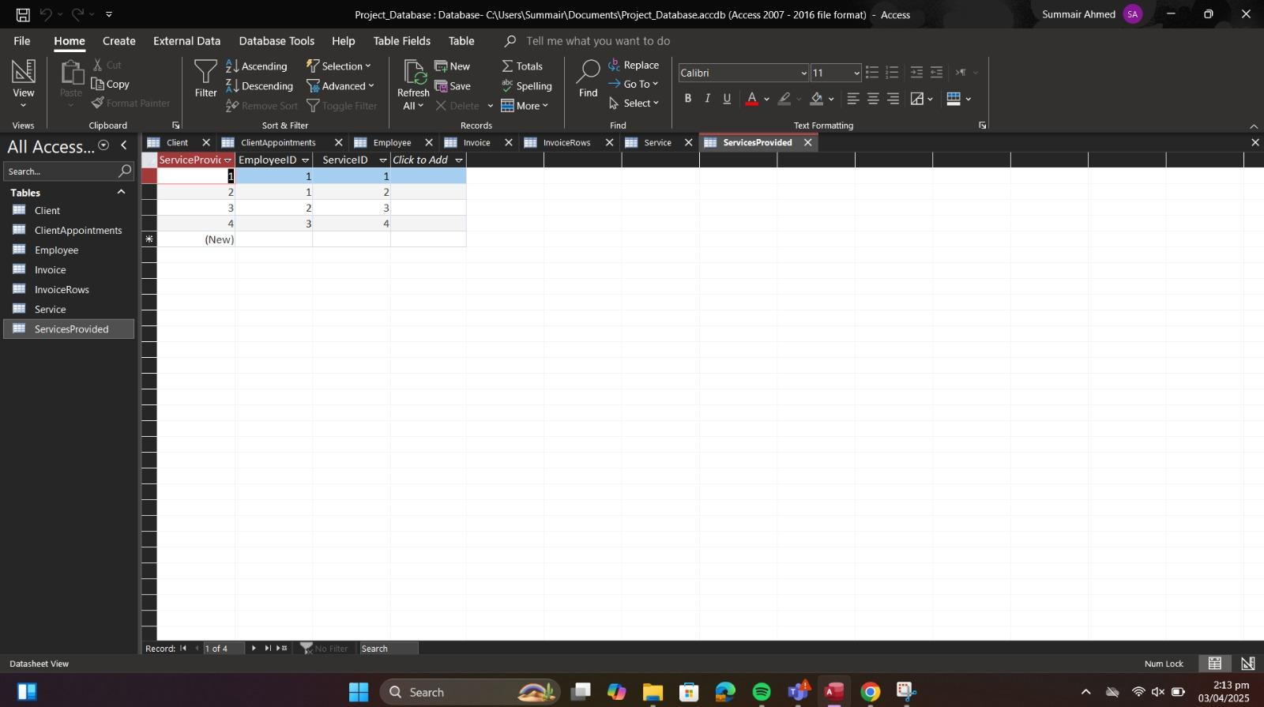

**ServicesProvided Table**

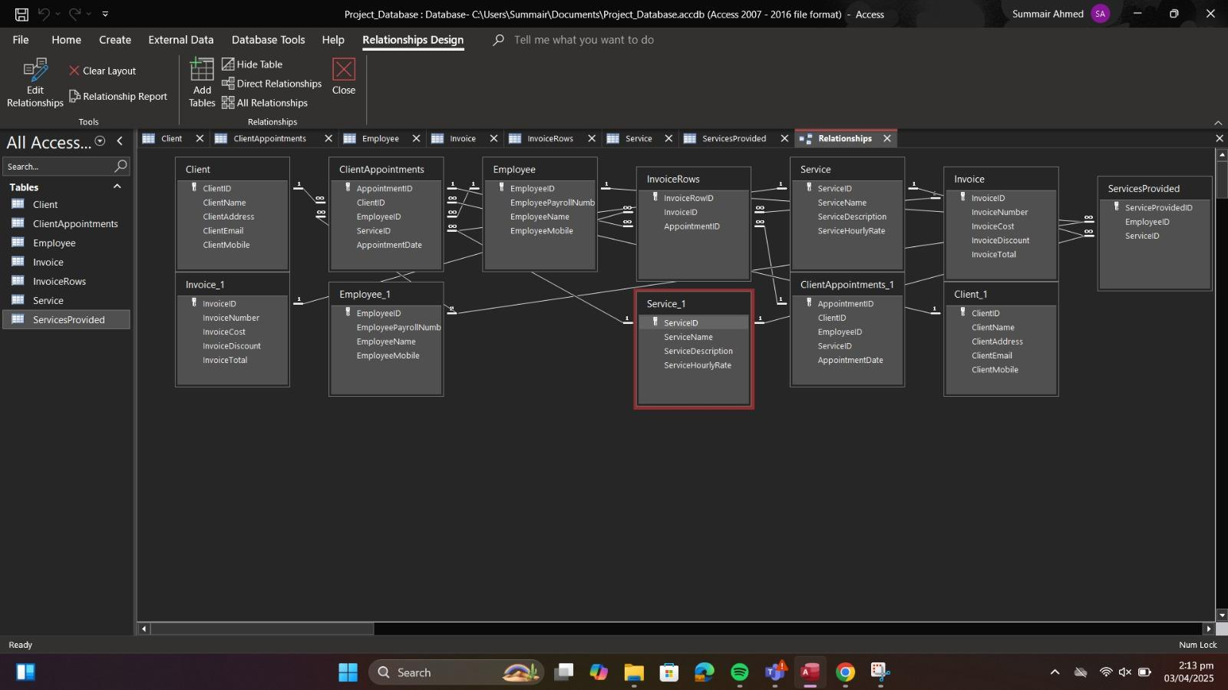

# Appendix C: ERD Diagrams / Visuals

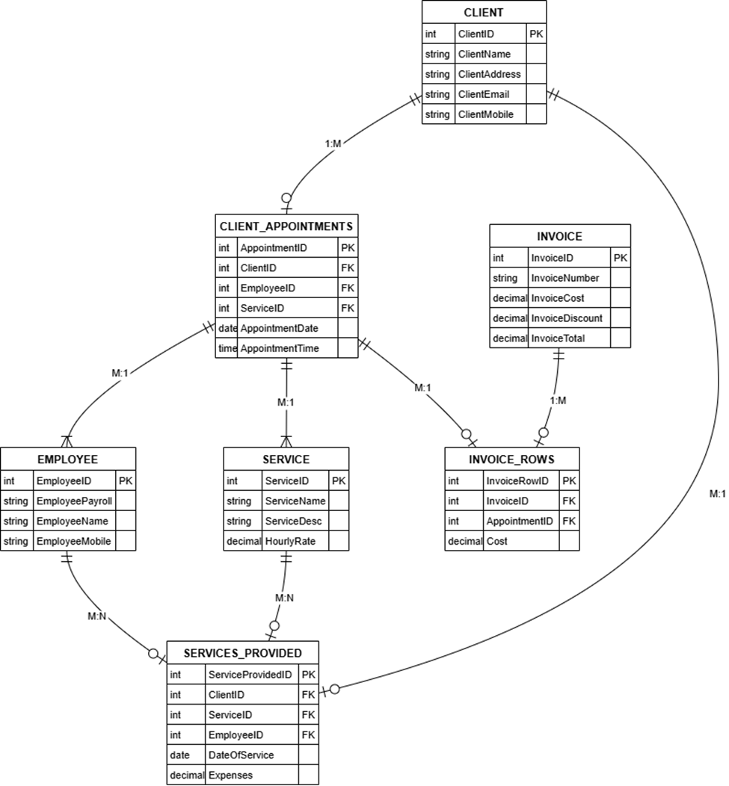

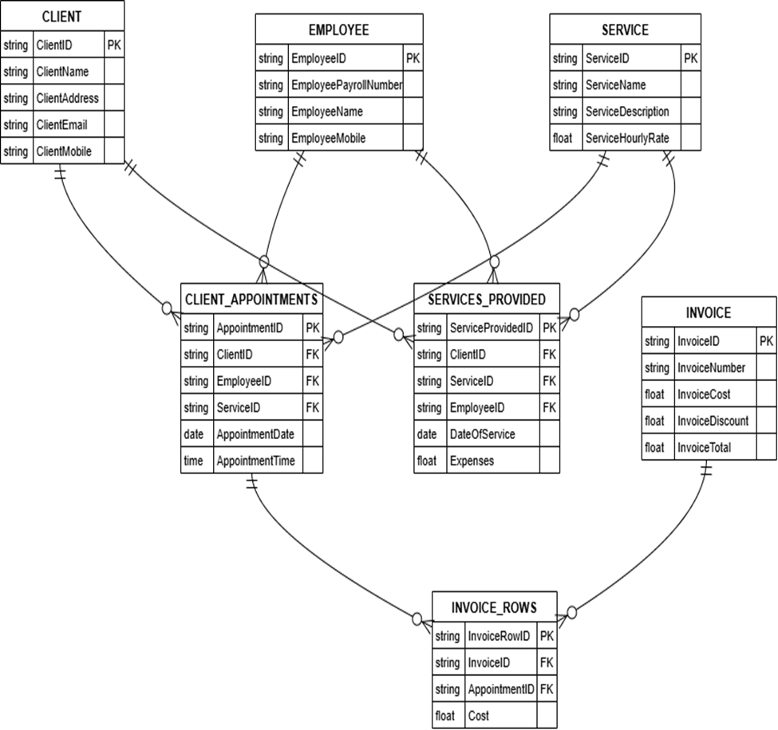

*Relational Schema*

# Appendix D: Application Form Screenshots

